Online Restaurant Reservation System

﷽



Table of Contents

1.7Definitions and Acronyms: 7

2.1 Project Planning 9

2.1.1 Feasibility Study 9

2.3.1 User Requirements 12

✓ Real-Time Table Availability 21

✓ User-Friendly Interface 21

✓ Automated Notifications 21

✓ Comprehensive Reservation Management 21

✓ Customizable Menu Management 22

✓ Enhanced Customer Engagement 22

✓ Scalable and Future-Proof Design 22

8 Conclusion 75



**Chapter 1**

**Introduction**

1.1Overview:

In today’s fast-paced digital environment, customer expectations around dining experiences have evolved far beyond the food itself. Modern diners prioritize convenience, reliability, and seamless interaction. This document outlines the functional and non-functional requirements for a **Restaurant Reservation and Management System (RRMS)**, aimed at enhancing both customer and restaurant administrator experiences.

1.2Objectives:

1. **Simplify and digitize the table reservation process**  
   Makes it easier and faster for customers to book tables without phone calls or manual records.
2. **Provide real-time visibility of available seating**  
   Helps customers instantly know which tables are free, reducing waiting time and overbooking issues.
3. **Offer a comprehensive platform for menu browsing and feedback collection**  
    Gives customers a clear view of the menu and lets them share opinions, improving service based on real feedback.
4. **Enable restaurant staff to efficiently manage reservations, tables, and menu updates**  
   Streamlines daily operations for staff, cutting down on errors and manual work.
5. **Increase customer engagement and satisfaction through seamless digital experiences**  
    A smooth, modern system keeps customers happy and encourages repeat visits.
6. **Improve operational efficiency for restaurants through automated notifications and reports**  
   Saves time by reducing the need for manual reminders and helps managers track performance through reports*.*

1.3Purpose:

In response to the growing demand for seamless and efficient dining experiences, we created the **Restaurant Reservation and Management System (RRMS)**. Our primary goal is to simplify and digitize the reservation process while enhancing operational efficiency for restaurant staff and management.

We aim to empower restaurants with modern tools that offer customers the convenience, reliability, and real-time service they expect from today’s hospitality industry. Through RRMS, we ensure that both customers and restaurant administrators enjoy an intuitive, interactive, and dependable experience.

RRMS offers comprehensive features covering every aspect of restaurant management, including real-time table availability, online reservations, digital menu browsing, and feedback collection. It also equips restaurant staff with advanced tools for managing reservations, tables, menus, and automated notifications, promoting smooth daily operations.

In addition to streamlining reservations, RRMS provides administrators with valuable insights through automated reports and notifications, supporting data-driven decision-making and improving overall restaurant performance.

By offering an all-in-one, user-friendly, and scalable system, RRMS aims to transform how restaurants manage their services, ensuring that customers leave satisfied and restaurant operations run smoothly from reservation to table service.

Scope:

* Customer side functionality:
  + View available tables in real-time
  + Make, modify or cancel reservations
  + Browse menus digitally
  + Submit feedbacks on the website
  + Receive reservation confirmations and reminders
* Administrator side functionality:
* Manage table availability and seating arrangements
* Create, edit, and remove menu items
* View and manage reservations
* Send and receive system notifications
* Generate daily, weekly, and monthly reports

1.4Out-of-scope:

* Payment processing and billing system
* Integration with external third-party delivery platforms
* In-app food ordering and delivery services
* Loyalty programs or promotional coupon systems

1.5General-constraints:

To ensure a reliable, secure, and user-friendly experience, the development and implementation of the **Restaurant Reservation and Management System (RRMS)** will adhere to the following constraints:

* **Cross-Platform Accessibility**  
  The system must be accessible via both web browsers and mobile devices, offering a responsive design that adjusts smoothly to different screen sizes and platforms.
* **Data Privacy and Security**  
  All customer information, reservation details, and administrative data must be securely stored and managed in compliance with **data protection regulations** such as GDPR or equivalent local policies.
* **Real-Time Data Synchronization**  
  Table availability, reservation status, and menu updates must be reflected in real time across all platforms to prevent conflicts, overbooking, and service delays.
* **Scheduled Maintenance Windows**  
  Any necessary system downtime for updates or maintenance must be scheduled during off-peak hours to minimize service disruption for both customers and administrators.
* **Scalability for Multi-Branch Management**  
  The system architecture should allow for future expansion to support multiple restaurant branches, enabling centralized control and reporting.

1.6Assumptions:

* Customers have access to internet-enabled devices
* The restaurant admin will maintain accurate table availability and menu details
* System downtime for maintenance will be scheduled during off-peak hours
* Staff will be trained to use the administrative system

## 1.7Definitions and Acronyms:

1. **RRMS**: Restaurant Reservation and Management System
2. **Admin**: Restaurant Administrator
3. **Reservation Slot**: A specific date and time window a table is reserved for
4. **Customer, User**: Food eater



**Chapter 2**

**Planning and Analysis**

## 2.1 Project Planning

### 2.1.1 Feasibility Study

#### Financial Feasibility

As a web-based platform, the **Restaurant Reservation and Management System (RRMS)** will incur costs primarily associated with hosting services and domain registration. The system’s bandwidth requirements are expected to be moderate, depending on reservation traffic and customer interaction levels.

The system will be built using **open-source and freeware technologies**, which helps minimize initial development costs. Regular maintenance, updates, and bug fixes will have associated operational expenses. providing clear benefits in terms of operational efficiency for restaurants and convenience for customers.

After evaluating the anticipated expenses against the potential operational value and customer satisfaction gains, it is evident that the **RRMS project is financially feasible**.

#### 2.1.2Technical Feasibility

**RRMS** will be developed using a combination of modern, widely adopted, and freely available technologies, including:

* **HTML, CSS & JavaScript** for the web-based user interface
* **PostgreSQL** as the primary database management system
* **Python (Flask)** for developing the RESTful API backend

All selected technologies are **open-source**, well-documented, and supported by large development communities. The technical skill requirements for these tools are accessible and align with the team’s capabilities. Additionally, the technologies are scalable and can support future enhancements such as multi-branch management or multilingual support.

In the initial phase, the system will be deployed on a **free or low-cost hosting environment** suitable for testing.

Given the compatibility of the selected technologies, the manageability of required technical skills, and the alignment of development timelines with implementation goals, the **RRMS project is technically feasible**.

2.2Need for new systems:

Our application introduces modern, customer-focused features and administrative tools that traditional restaurant reservation systems lack. The following enhancements set our system apart

**Real-Time Table Availability & Visual Layout:**  
The RRMS will display **real-time table availability** alongside **visual representations of the dining space**. Customers can view seating arrangements and select preferred tables based on location, capacity, and availability — a feature rarely available in older systems.

**Automated Reservation Notifications:**  
Unlike existing systems, RRMS will send **automated notifications via email or SMS** to customers and restaurant staff. This includes **reservation confirmations, reminders 24 hours and 1 hour before the booking, alerts for modifications or cancellations, and notifications on customer no-shows** — ensuring better communication and reducing missed reservations.

**Menu Preview Before Booking:**  
Customers can conveniently **view the restaurant’s full menu before making a reservation**. This enables informed dining decisions and improves customer satisfaction, a feature often missing from older reservation platforms.

**Feedback and Review System:**  
The application will allow customers to **submit feedback and reviews after their dining experience**. This supports restaurants in gathering valuable insights and maintaining service quality — a critical yet overlooked function in many legacy systems.

**Centralized Table and Reservation Management Dashboard:**  
For restaurant administrators, RRMS offers a **comprehensive and centralized dashboard** for managing tables, reservations, menus, and notifications in one place. This greatly improves operational efficiency compared to scattered or manual management methods.

2.3 System analysis

### 2.3.1 User Requirements

**For Users (Customers)**

* **View Available Tables and Make Reservations Easily**  
  Customers should be able to effortlessly **view available tables in real-time through a visual table layout**. They can select preferred time slots and table locations, then instantly confirm their reservation. This offers a seamless and efficient booking experience, reducing wait times and miscommunication.
* **Browse the Restaurant Menu Before Booking**  
  Before confirming a reservation, customers can **access the full restaurant menu directly through the application**. This allows them to explore available dishes, prices, and special offers — helping diners make informed decisions and enhancing their overall dining experience.
* **Receive Automated Notifications and Reminders**  
  Customers will receive **automated reservation confirmations and reminders via email or SMS**. Notifications will be sent **24 hours and 1 hour before their scheduled booking**, as well as alerts for any modifications or cancellations. This ensures customers remain updated and reduces the chance of missed reservations.
* **Submit Feedback and Reviews After Dining**  
  After their visit, customers can **submit reviews and feedback about their dining experience**. This enables them to share suggestions, rate service, and contribute to the restaurant’s quality improvement efforts, fostering customer engagement and loyalty.

**For Admins (Restaurant Admin)**

* **Manage Tables and Visual Layout**  
  Admins can **create, update, and manage table information** including table numbers, capacities, and locations. They can also **upload images or layouts of the dining area** for customers to view during the booking process.
* **Manage Reservations and Monitor Real-Time Availability**  
  Admins can **view, accept, modify, or cancel reservations** in real-time. The system provides a centralized dashboard displaying current bookings, available slots, and customer information — optimizing dining room management.
* **Manage Menu and Special Offers**  
  Restaurant admins can **add, edit, or remove menu items**, set prices, and upload images. They can also highlight daily specials or limited-time offers to attract customers and promote seasonal dishes.
* **Receive System Notifications and No-Show Alerts**  
  Admins will receive **real-time alerts for new reservations, cancellations, and last-minute changes**. In case of customer no-shows, the system will automatically notify the admin, allowing for efficient table reallocation.

2.3.2 Domain requirements

**The database server must have sufficient memory and processing power** to support concurrent access from multiple customers and restaurant admins, handling reservations, menu updates, and real-time table availability without delays or downtime.

**The system must be designed with scalability in mind**, ensuring that future updates, new features, or integrations (like loyalty programs, payment gateways, or third-party delivery systems) can be incorporated smoothly without affecting existing operations.

**Before performing any database operations (insert, update, delete), the system must validate all input values** to maintain data integrity, prevent invalid or duplicate entries, and avoid runtime errors.

**The application must support updates for upcoming technologies, accessories, or device models**, ensuring consistent performance across new web browsers, mobile platforms, and user devices.

T**he database should be automatically backed up at scheduled intervals** to protect against data loss or corruption. In the event of system failure, the backup will ensure business continuity and quick recovery of all reservation, menu, and customer data.

2.3.3 System requirements

2.3.3.1 Hardware requirements

**For Web Server & Hosting:**

* Minimum **4 GB RAM** (8 GB recommended for production)
* **Intel i5 processor** or higher
* Minimum **40 GB storage space**
* SSD storage preferred for better read/write performance
* Reliable power backup for continuous server operation

**For Client Devices:**

* Any modern device with **internet access** (desktop, laptop, tablet, smartphone)
* Minimum **2 GB RAM**
* Modern browser (Google Chrome, Firefox, Edge, Safari)

2.3.3.2 Software requirements

**Web Application Technologies:**

* **React.js** for responsive, interactive front-end UI
* **Python (Flask)** for building the backend RESTful API
* **PostgreSQL** as the database management system

**Server Operating System:**

* **Linux (Ubuntu 20.04 LTS)** recommended for security and reliability
* Alternatively, **Windows Server 2019+**

**Other Software:**

* **Nginx** or **Apache** as a web server
* **Postman** for API testing
* **Git** for version control
* **Docker** (optional, for containerized deployment)

2.3.4 Functional requirements

* **User Registration**
* **Description:**  
  This feature enables users (both customers and restaurant admins) to securely create an account within the system by providing necessary details such as name, email, password, and role selection.
* U**ser Login**
* **Description:**  
  Allows registered users to access their existing accounts by entering valid credentials. Customers can view their reservations and personal details, while admins can access reservation and menu management tools.
* **Table Reservation**
* **Description:**  
  Enables customers to view available tables in real-time, select preferred time slots, and confirm reservations. It also provides visuals of the table layout to help users choose seating based on location.
* **Reservation Management**
* **Description:**  
  Allows customers to view, modify, or cancel their reservations. For restaurant admins, this feature enables managing reservation lists, adjusting availability, and handling customer no-shows.
* **Menu Viewing and Management**
* **Description:**  
  Allows customers to browse the restaurant’s menu before making a reservation. Restaurant admins can add, edit, or remove menu items and update prices or availability.
* **Table Management**
* **Description:**  
  Gives restaurant admins control over specifying table locations, uploading images, and adjusting availability for different shifts or events.
* **Notifications**
* **Description:**  
  Automatically sends email or SMS notifications to customers for reservation confirmations, reminders (24 hours and 1 hour before), and alerts for cancellations or modifications. Admins are notified of customer no-shows.
* **Feedback and Reviews**
* **Description:**  
  Allows customers to submit feedback or reviews about their dining experience after a reservation, contributing to service improvement.

2.3.5 Non-Functional requirements

(1) **Performance:** The system shall respond to the request from the user in less than 3 seconds. The system shall be reliable and flexible. The system should start in less than 6 sec.

(2) **Safety and Security:** The system shall ensure that only authorized users are able to gain access. The system shall distinguish between authorized and nonauthorized users. All user’s entered information must be encrypted.

(3) **Usability:** The system shall have user-friendly interface. The system shall be easy to use by different users.

(4) **Availability:**

The system shall be available 24 hours a day.

System functionalities must be always available.

(5) **Reliability:**

The system shall be reliable and do not have data validation failures.

workspace information must be up to date.

(6**) Compatibility**

The Front-end and the back-end must be compatible to work together

for an extended period.

The Backend and the Database must be compatible to work together

for an extended period.

2.4 System advantages

### ****Real-Time Table Availability****

* Allows customers to view available tables instantly and make reservations without delays.
* Minimizes overbooking or double-reservations through automated, up-to-date availability management.

### ****User-Friendly Interface****

* Designed with a clean, intuitive UI for both customers and restaurant admins.
* Simplifies the process of booking, managing reservations, viewing menus, and receiving notifications.

### ****Automated Notifications****

* Sends automatic email or SMS confirmations upon reservation completion.
* Issues reminders 24 hours and 1 hour before scheduled reservations, reducing no-shows.
* Notifies admins instantly in case of reservation cancellations or modifications.

### ****Comprehensive Reservation Management****

* Enables restaurant admins to efficiently manage tables, reservations, and customer feedback from a centralized platform.
* Allows customers to easily view, modify, or cancel their bookings as needed.

### ****Customizable Menu Management****

* Lets restaurants update their menu items, images, and descriptions in real-time.
* Ensures customers always have access to the latest menu offerings before booking.

### ****Enhanced Customer Engagement****

* Integrated feedback and review feature to gather customer opinions and experiences.
* Live chat support enables real-time issue resolution and interaction, enhancing customer satisfaction.

### ****Scalable and Future-Proof Design****

* Built with modern technologies like React, Flask (Python), and PostgreSQL for reliability and scalability.
* Flexible architecture ready to accommodate future enhancements such as loyalty programs, mobile app integration, and analytics dashboards.



**Chapter 3**

**System design**

**3.1 ERD**

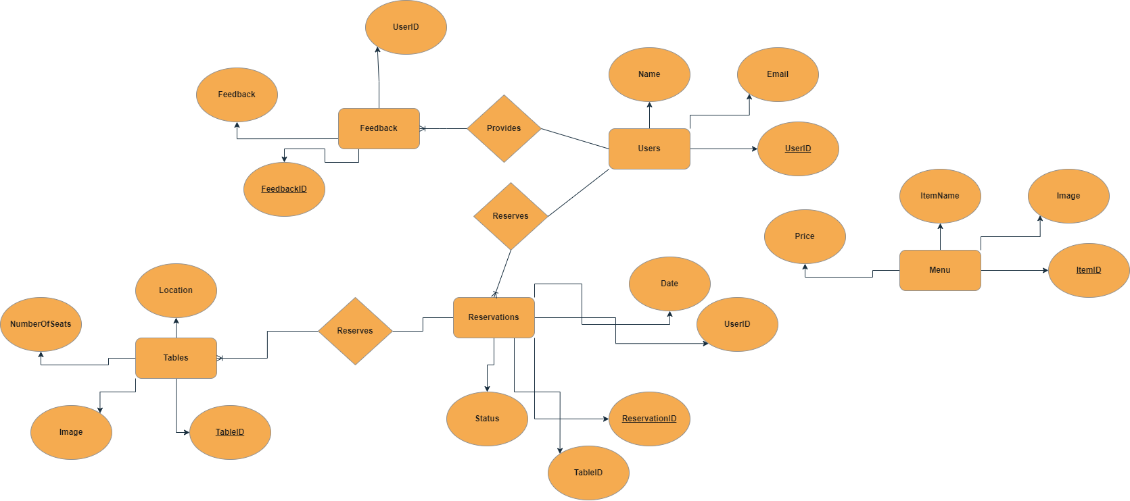

**3.1 Schema**

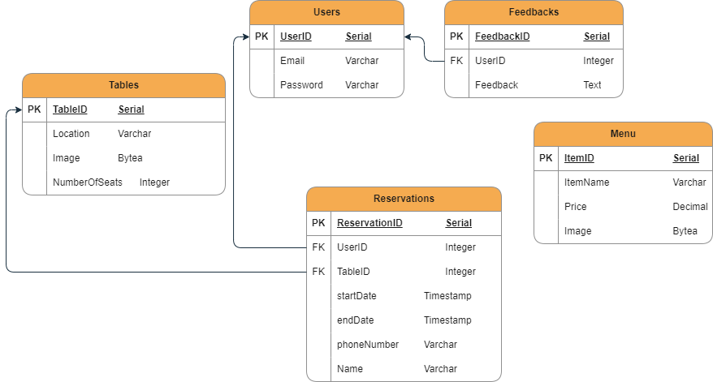

**3.2 Use case diagram**

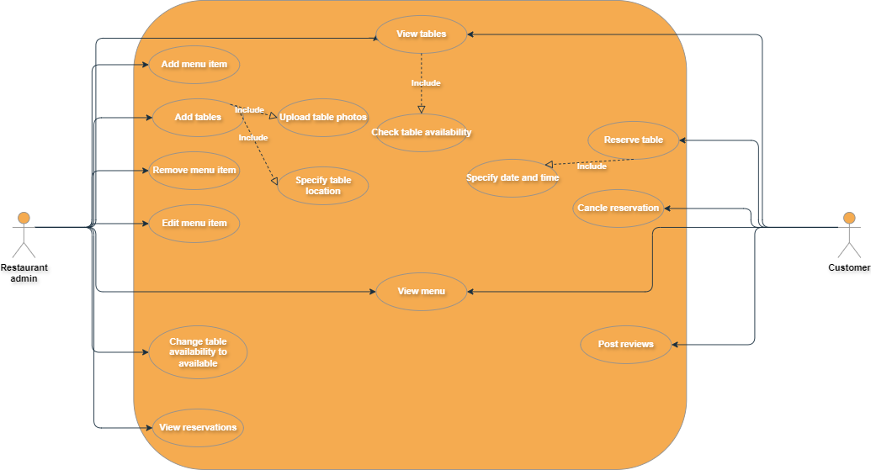

**3.3 Sequence diagram**

**1) Signup**

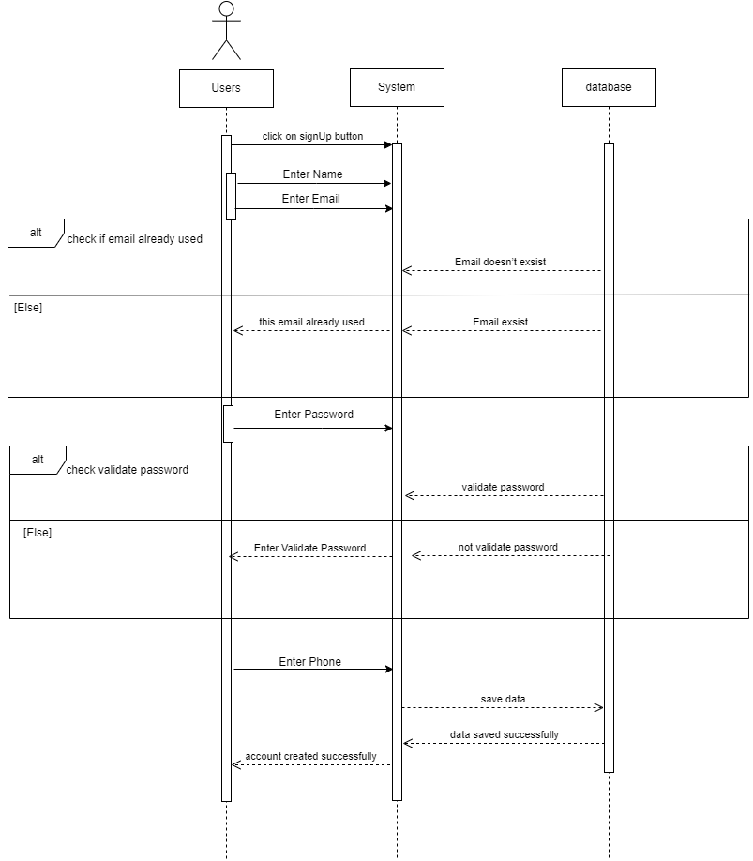

**2) Login**

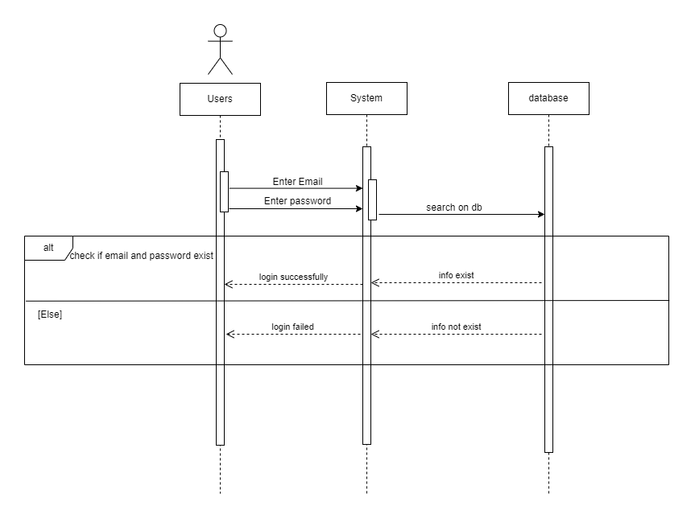

**3) Admin table adding**

**3) Adding tables (Admin)**

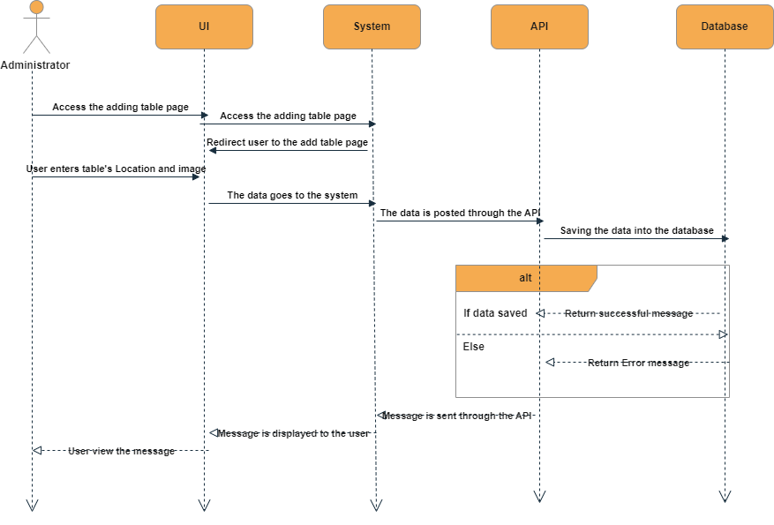

**4) Modifying tables (Admin)**

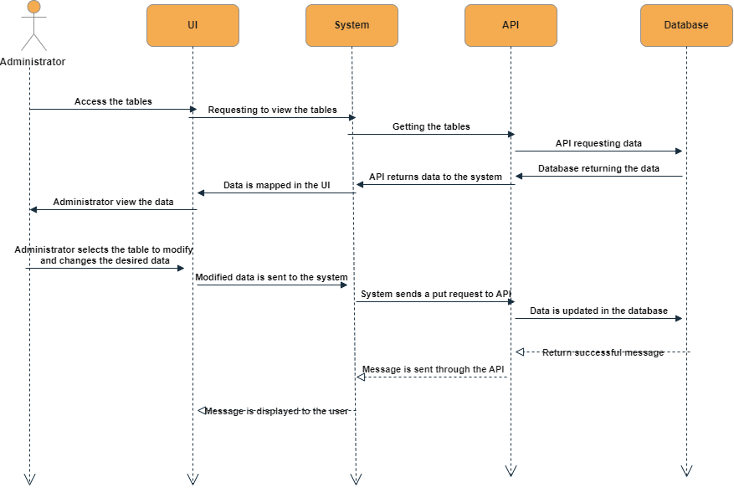

**5) Deleting table (Admin)**

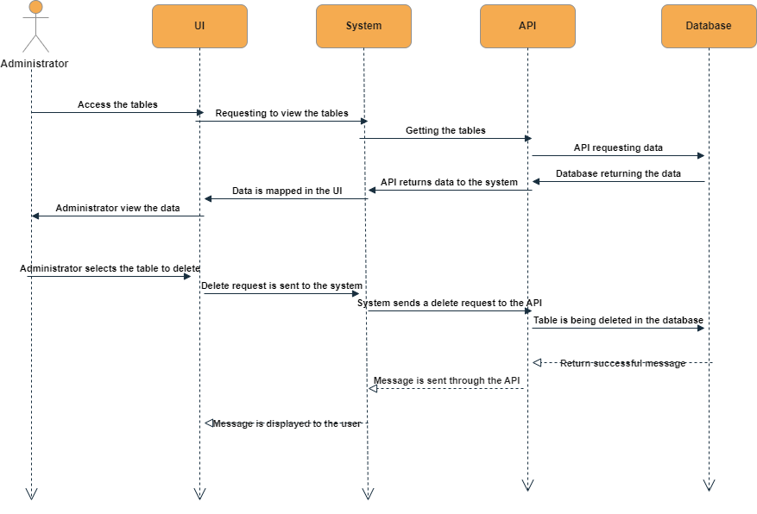

**6) Add menu item (Admin)**

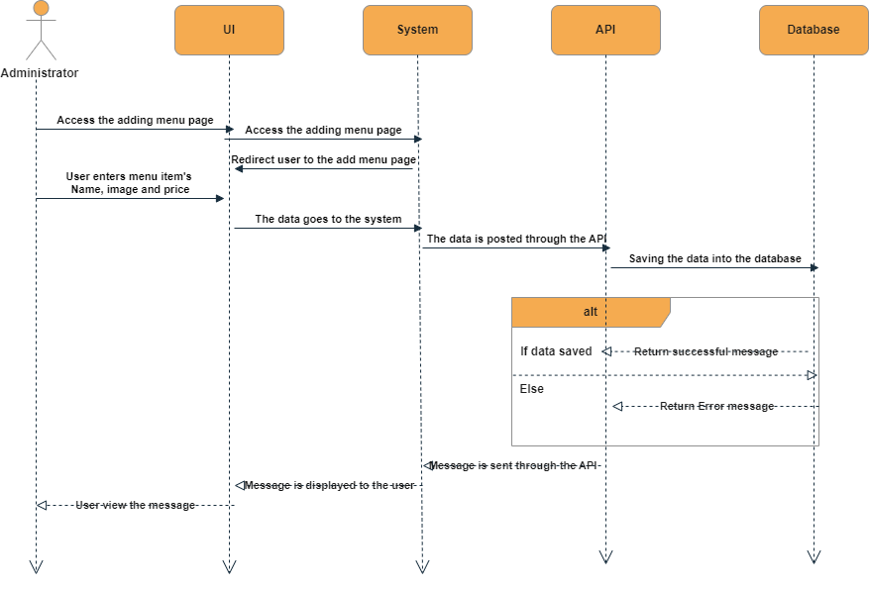

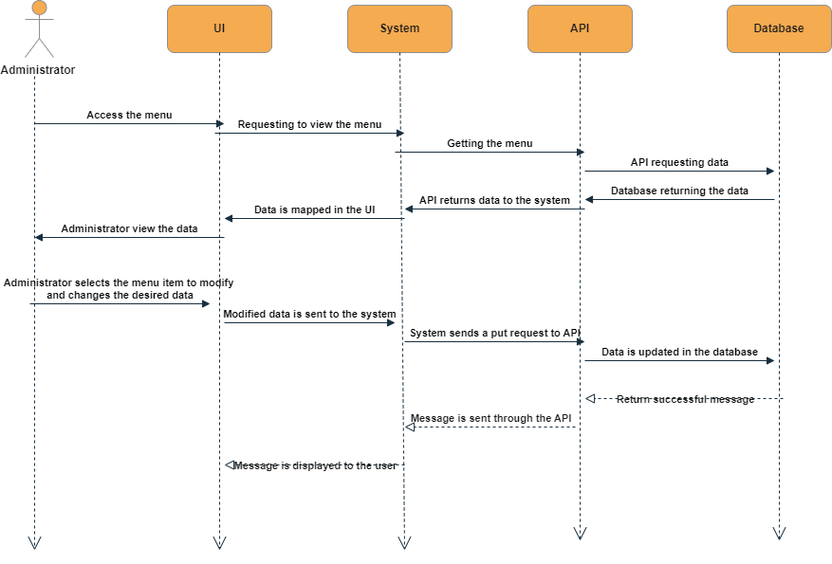**7) Modifying menu item (Admin)**

**8) Deleting menu item (Admin)**

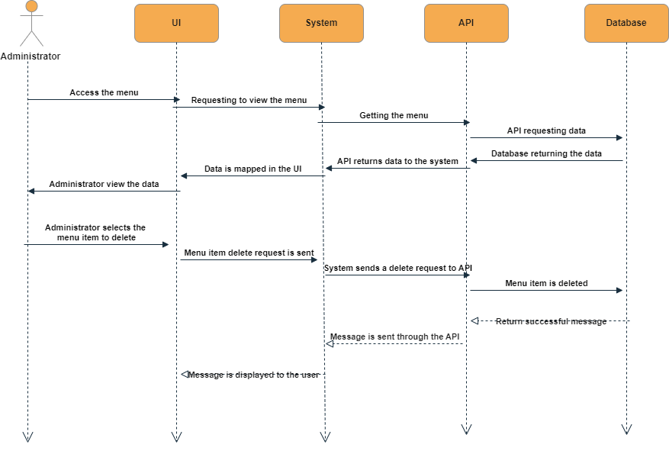

**9) Reserve table (Customer)**

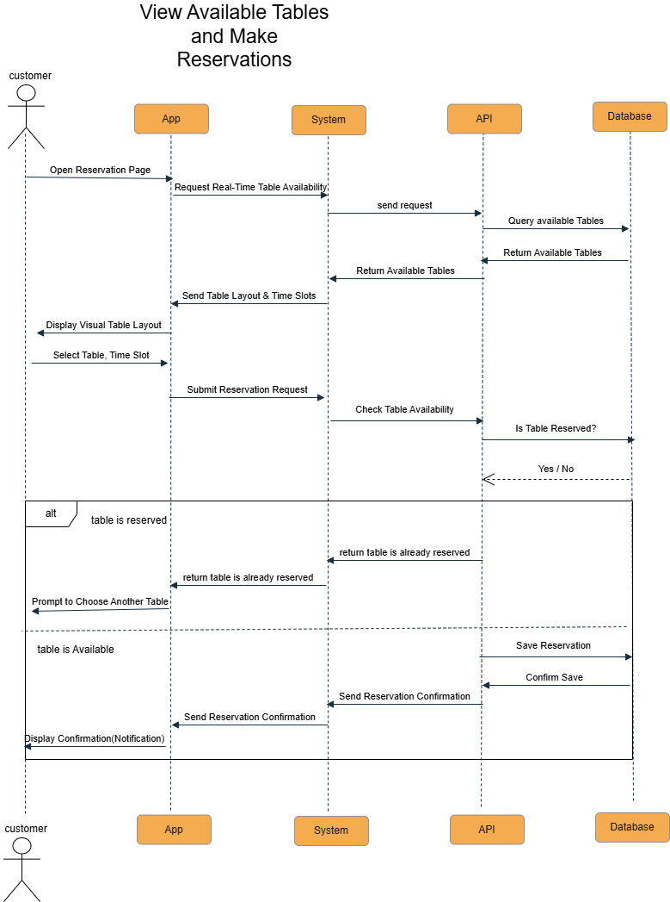

**10) Cancel reservation (Customer)**

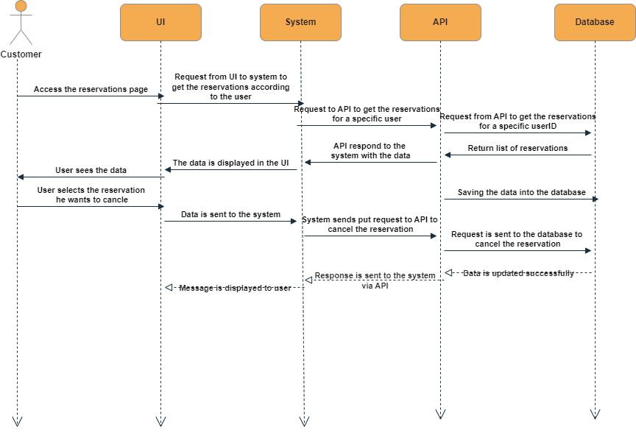

**11) Browse menu**

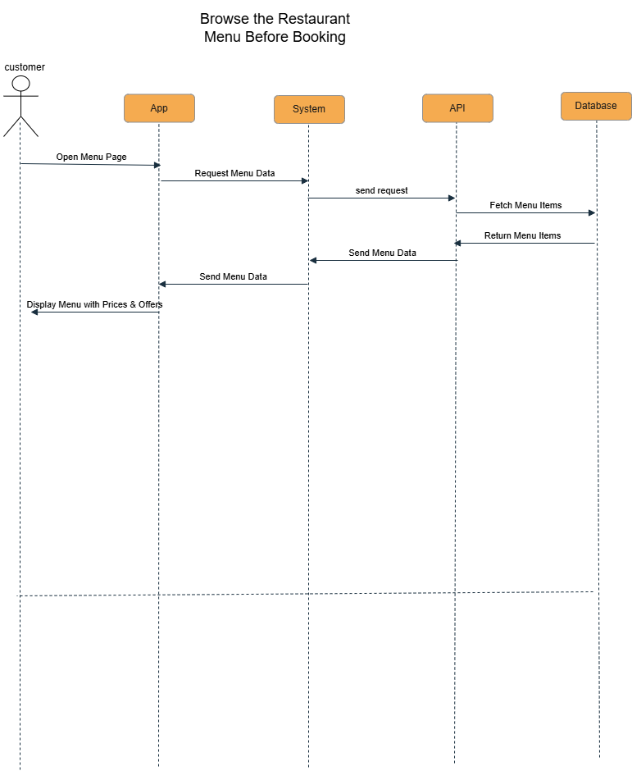

**12) Post feedback**

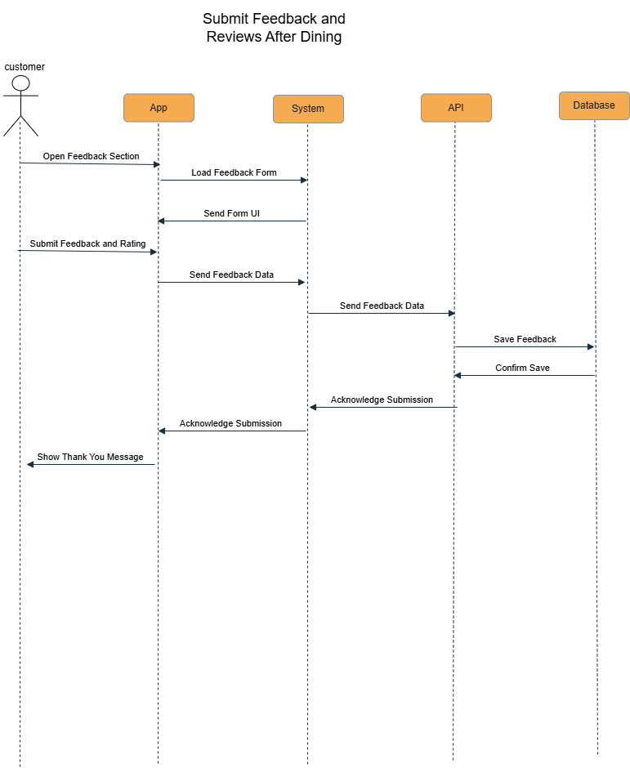



**Chapter 4**

**UI/UX**

**4.1 UI / UX implemented**

** using**

**4.2 Login Page**

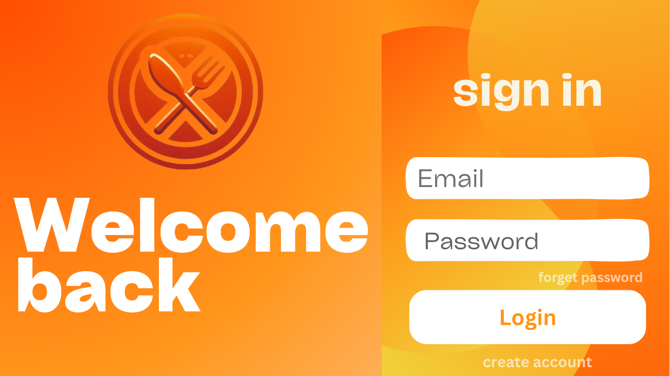

**4.3 Signup Page**

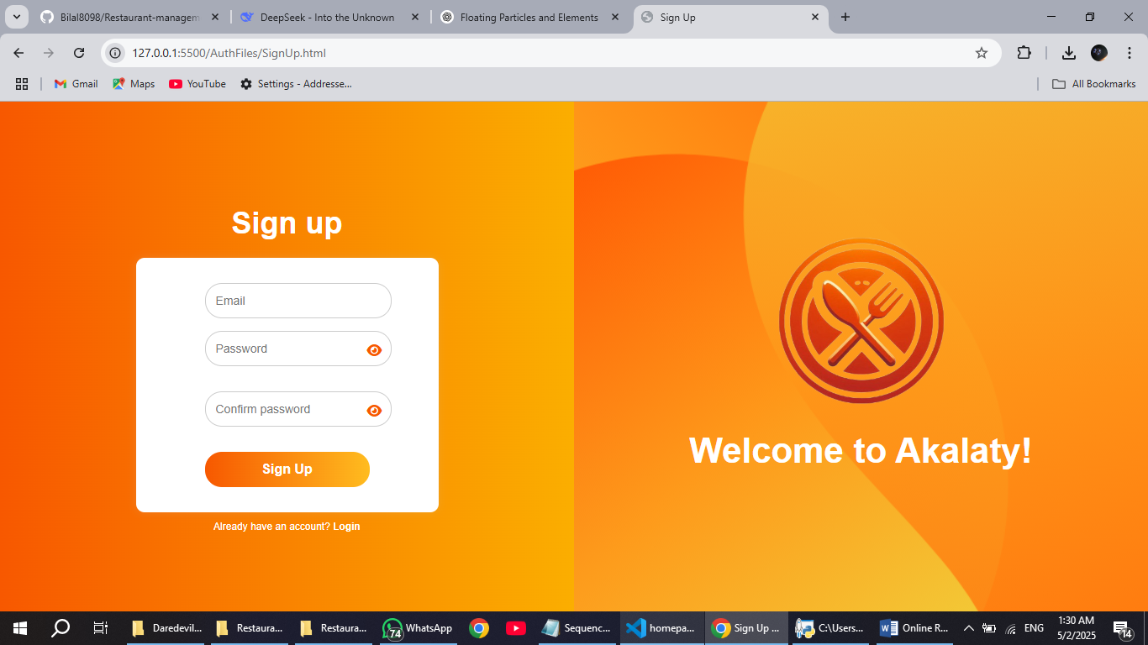

**4.4 Homepage**

**4.4.1 Header**

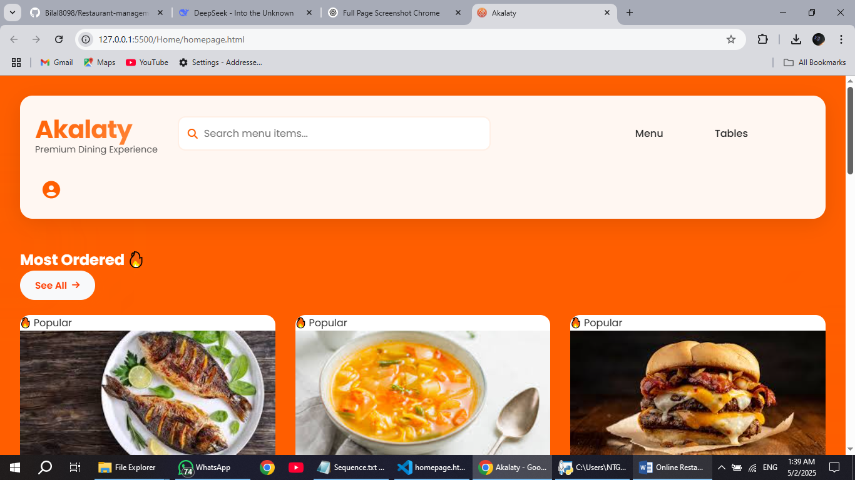

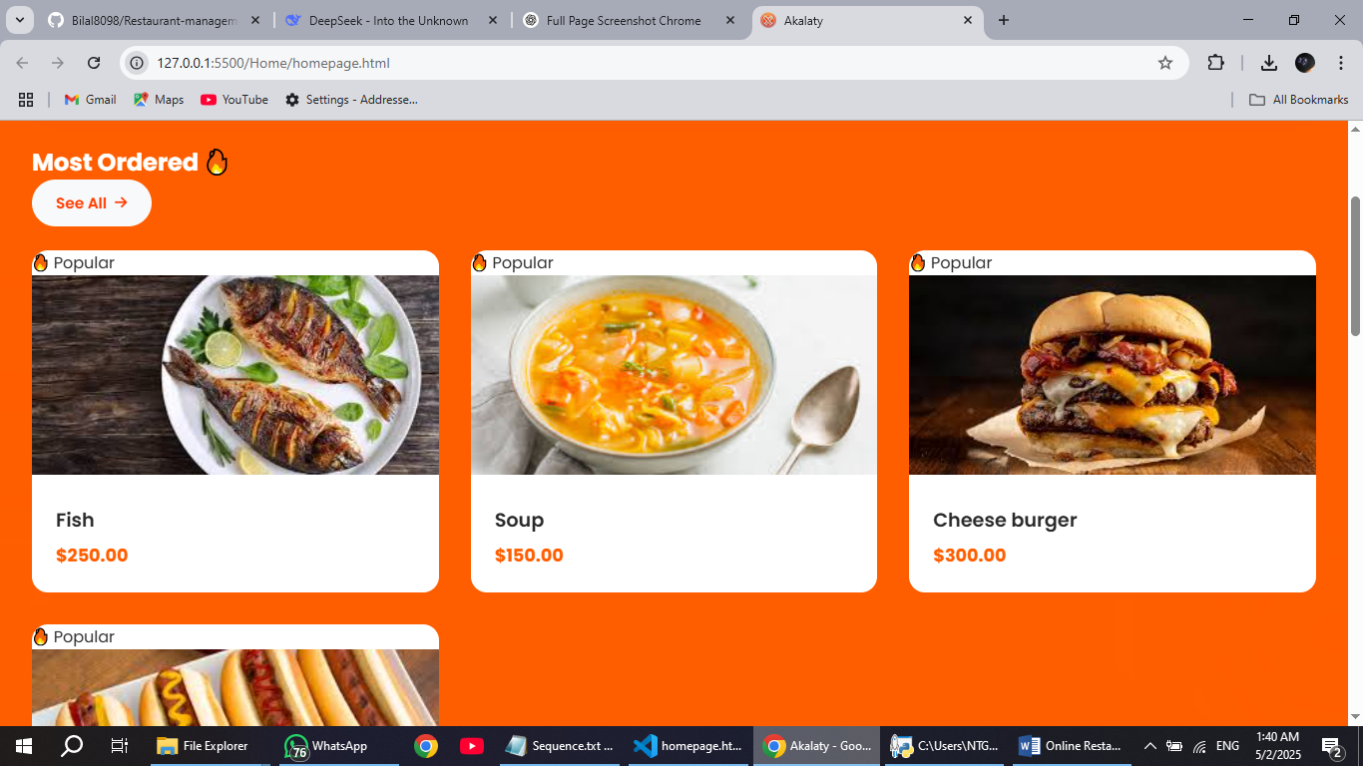**4.4.2 Menu section**

**4.4.3 Tables section**

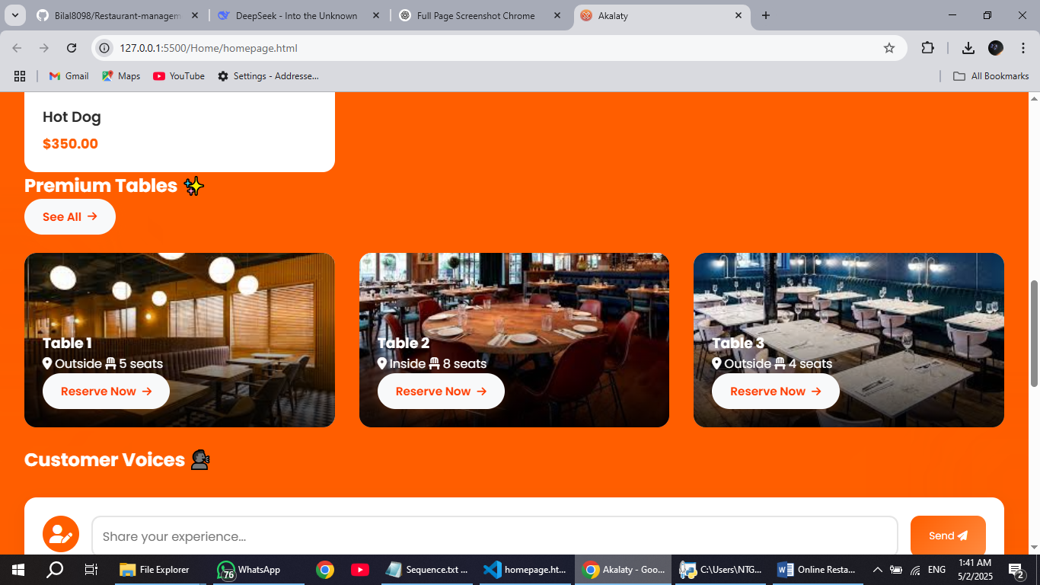

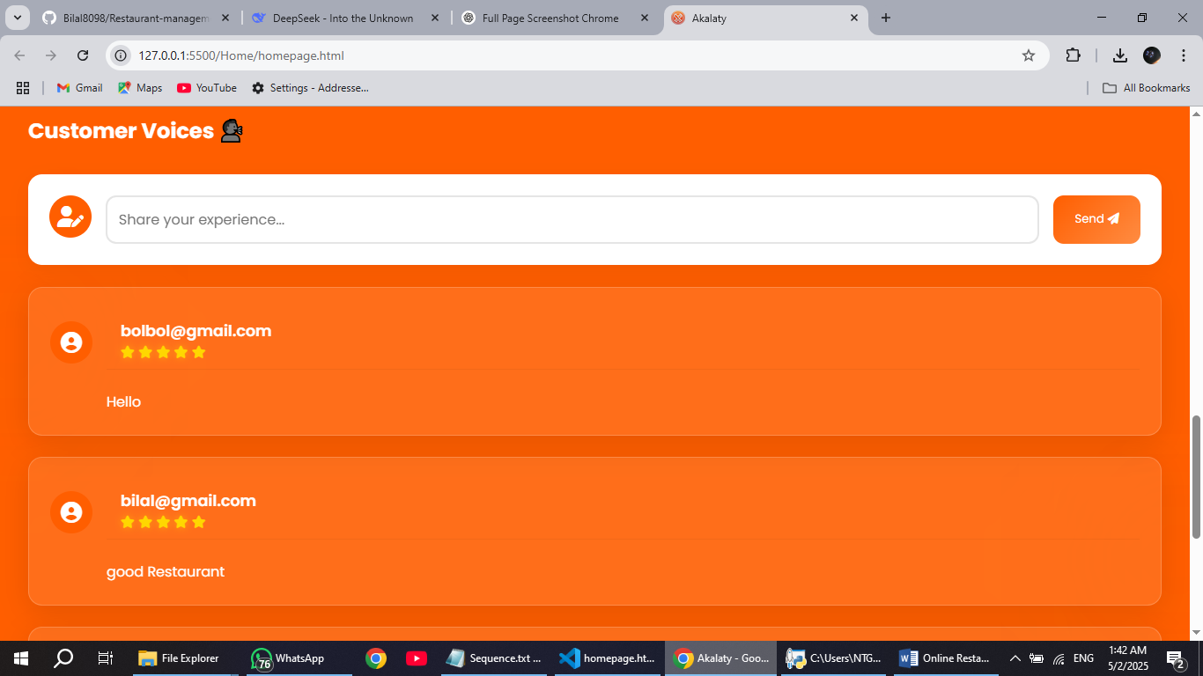**4.4.4 Feedbacks section**

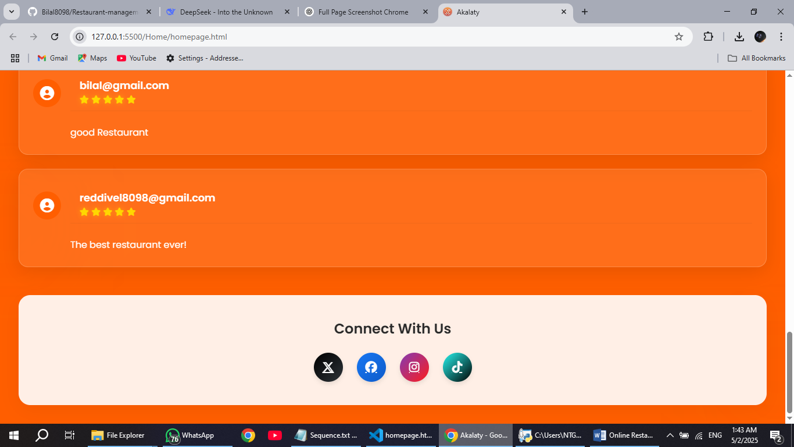**4.4.5 Contact us section**

**4.5 Menu page**

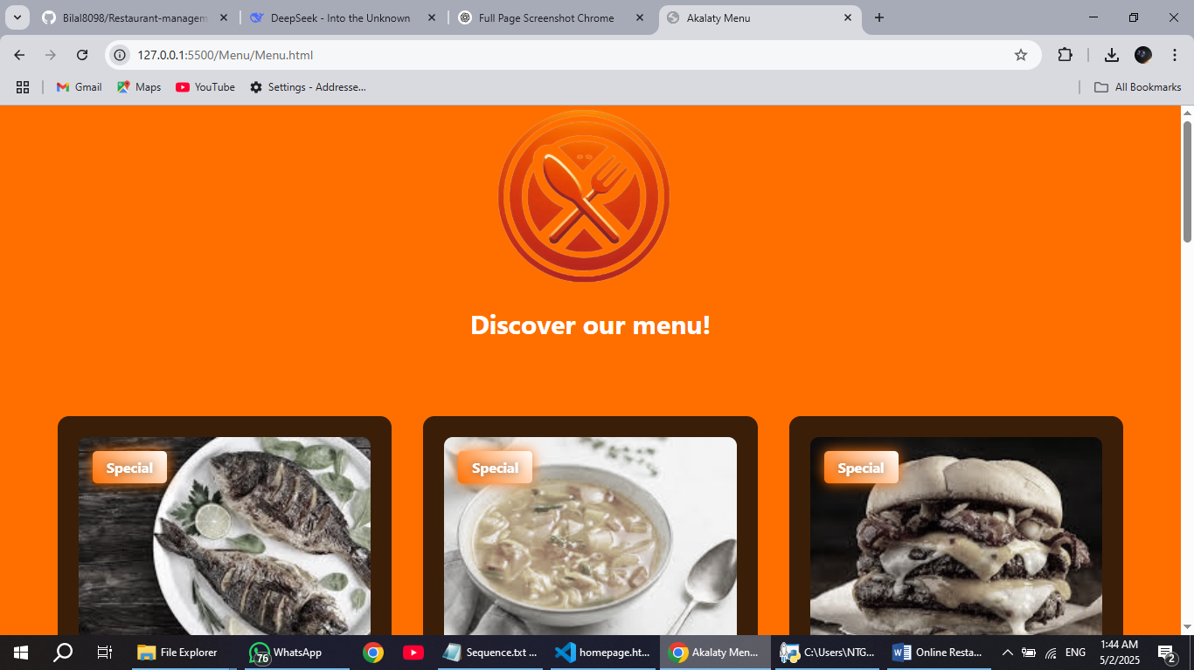**4.5.1 Heading**

**4.5.2 Menu page Content**

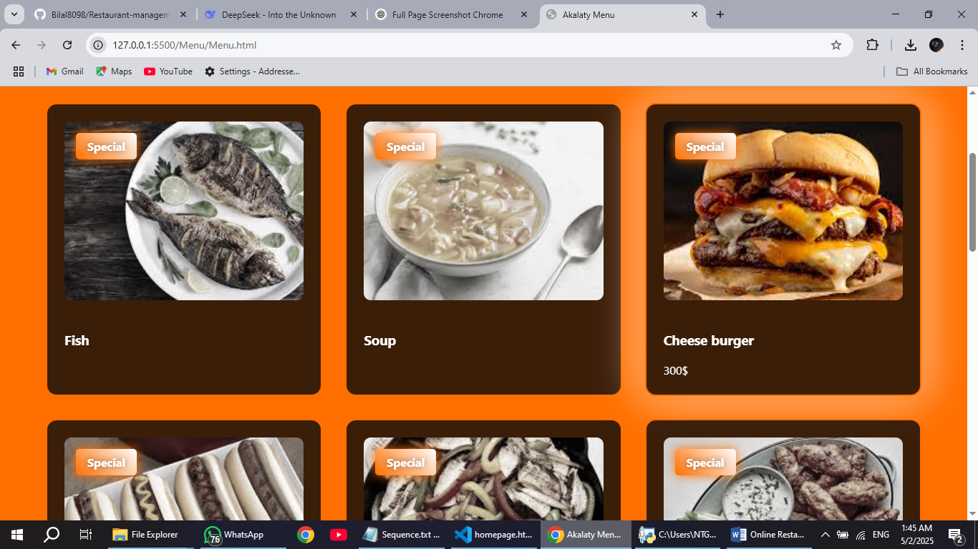

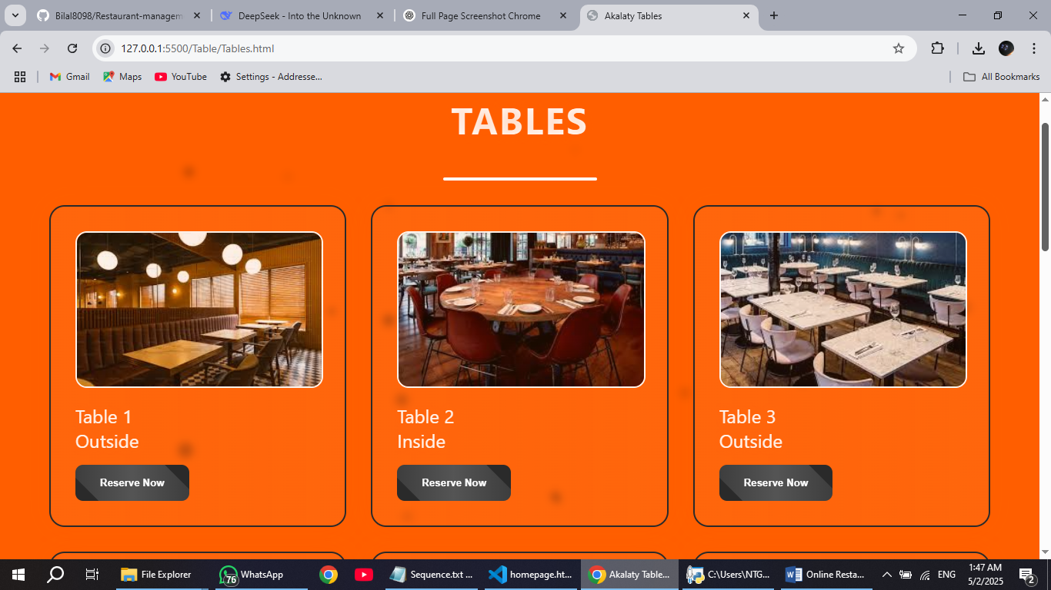**4.6 Tables page**

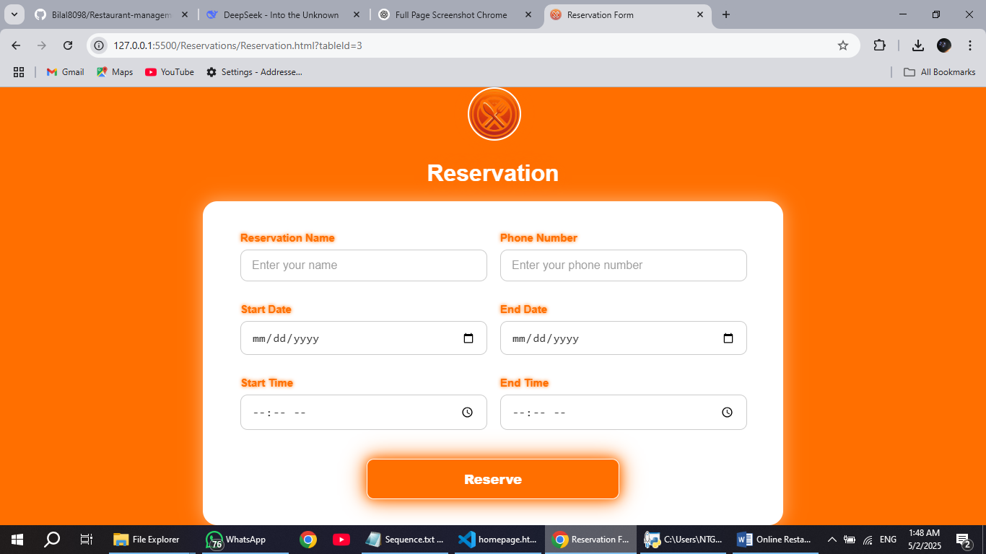**4.7 Reservation form**

**4.8 Email confirmation**

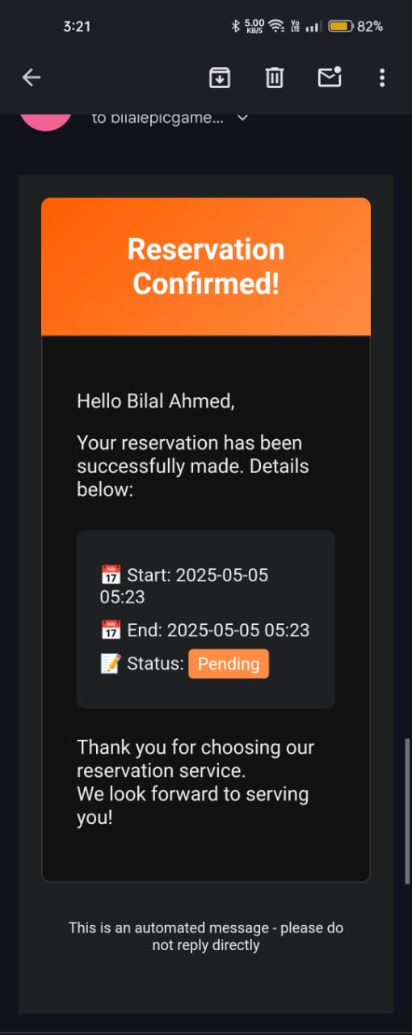

**4.9 Profile page**

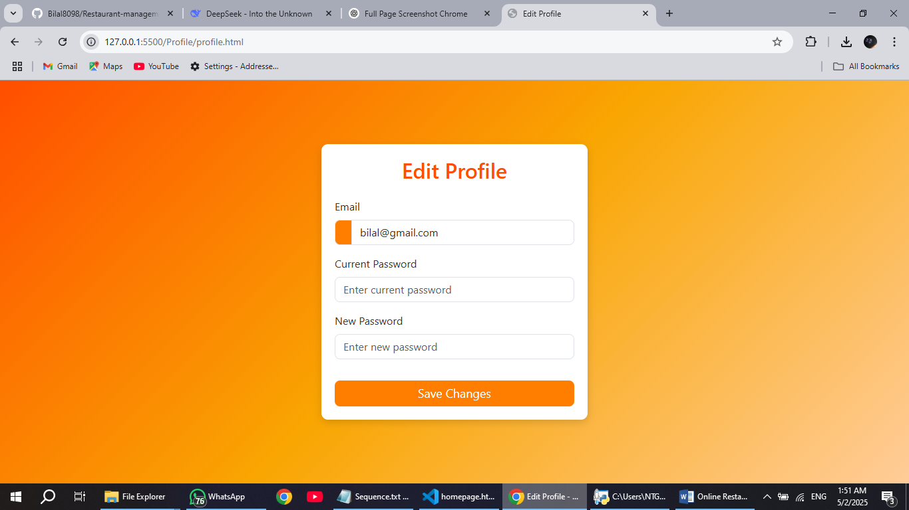

**4.8 Admin main page**

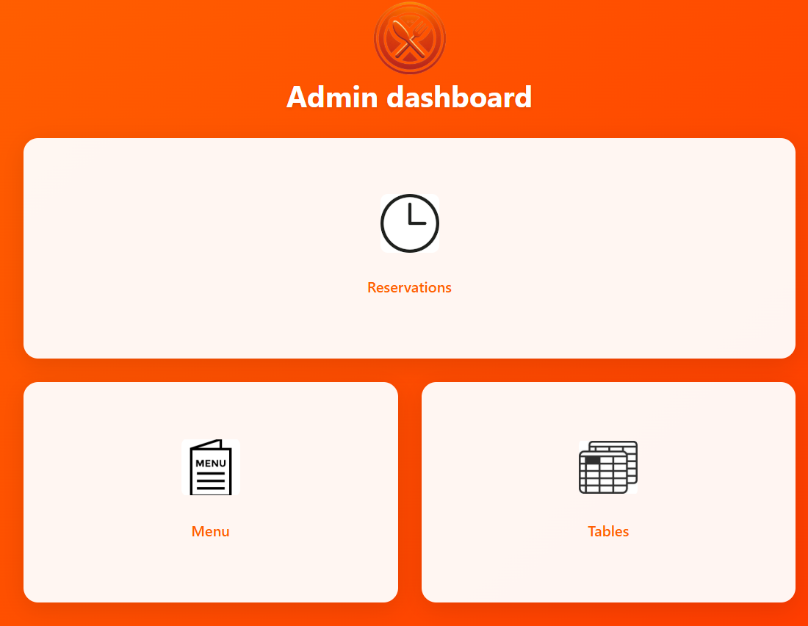

**4.9 Reservation view page**

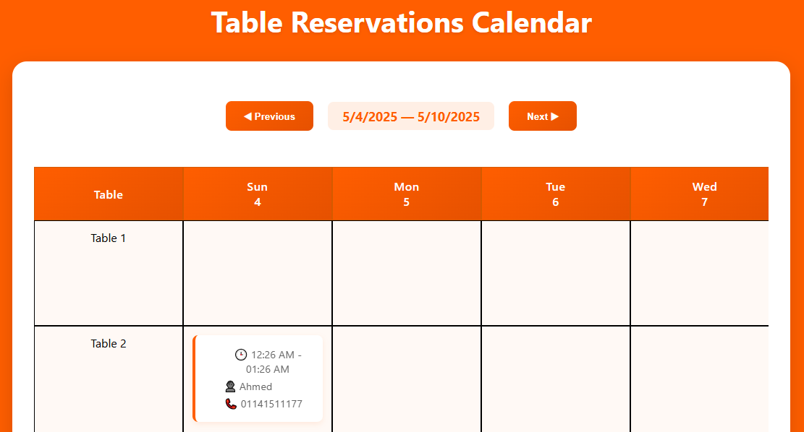

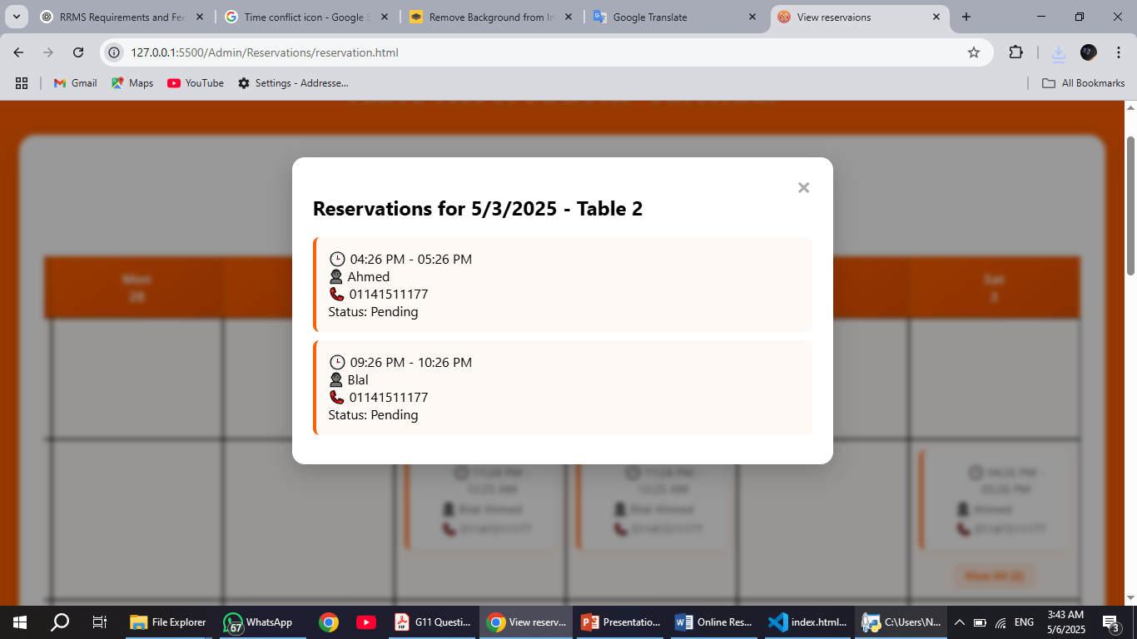

**4.10 Admin view menu & editing or delete**

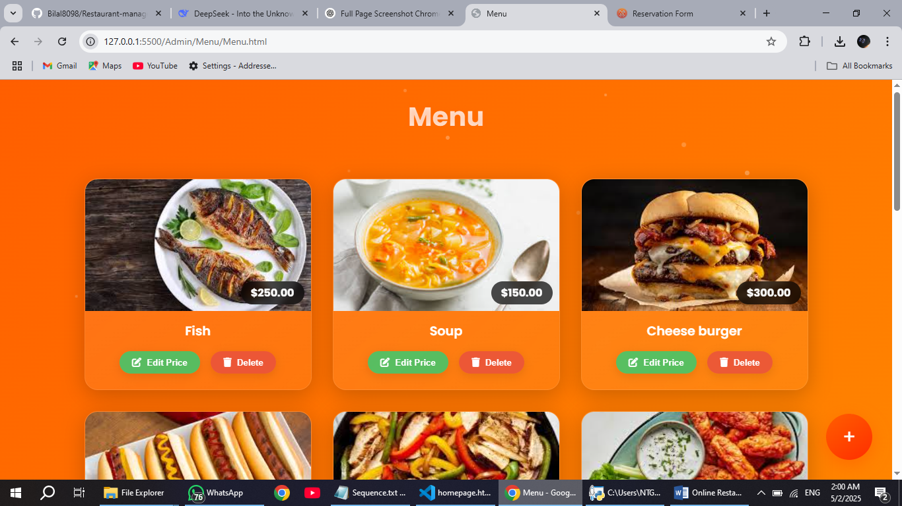

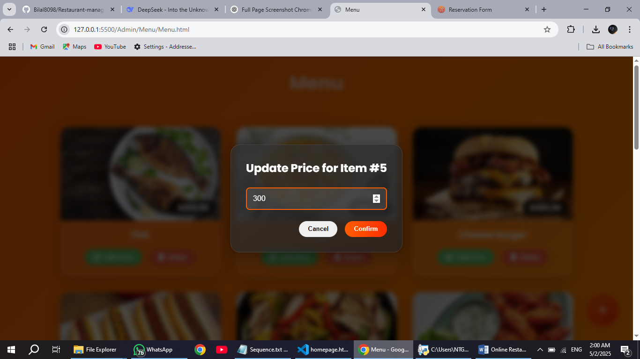

**4.11 Admin add new menu item**

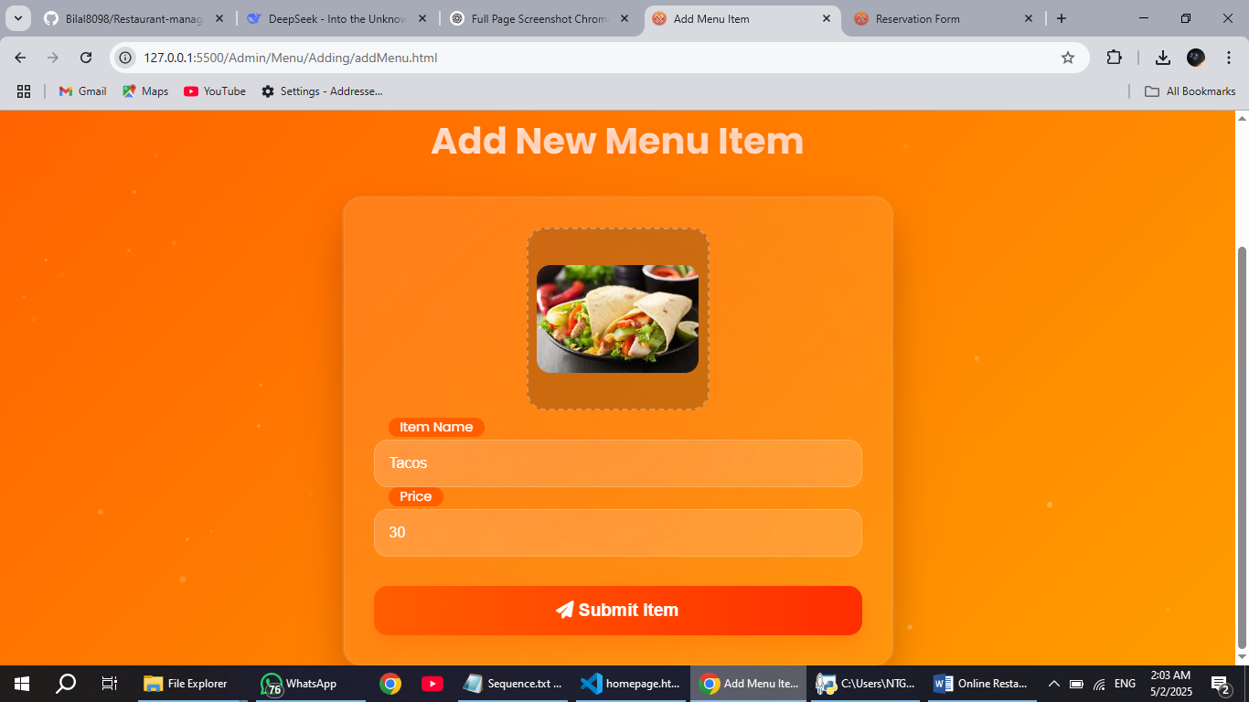

**4.12 Admin view tables & delete them**

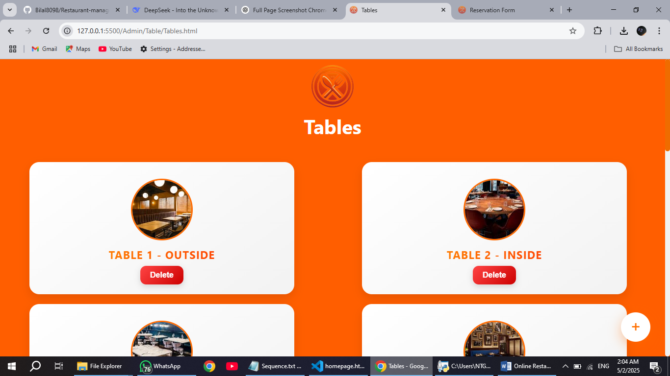

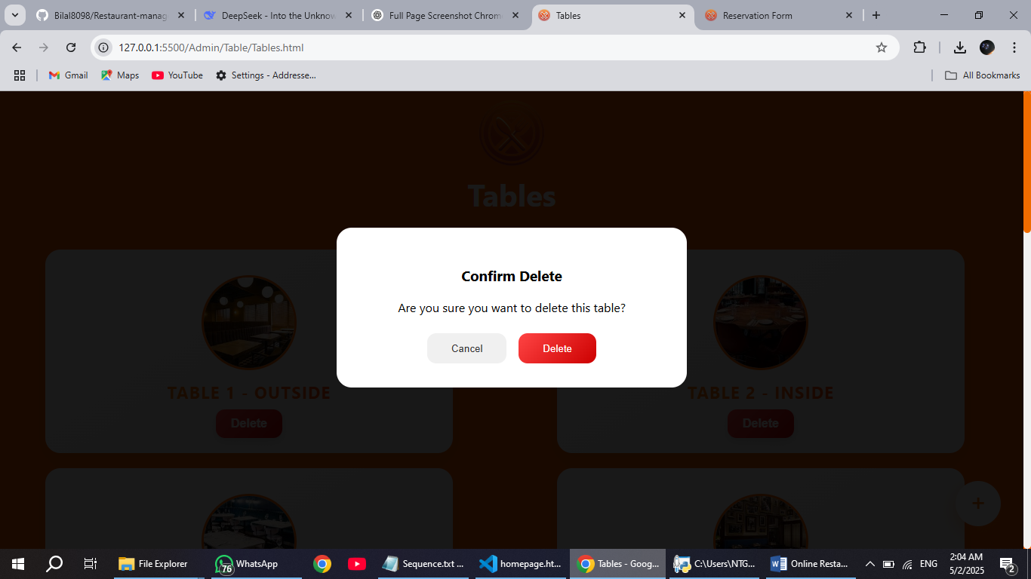

**4.13 Admin add new table**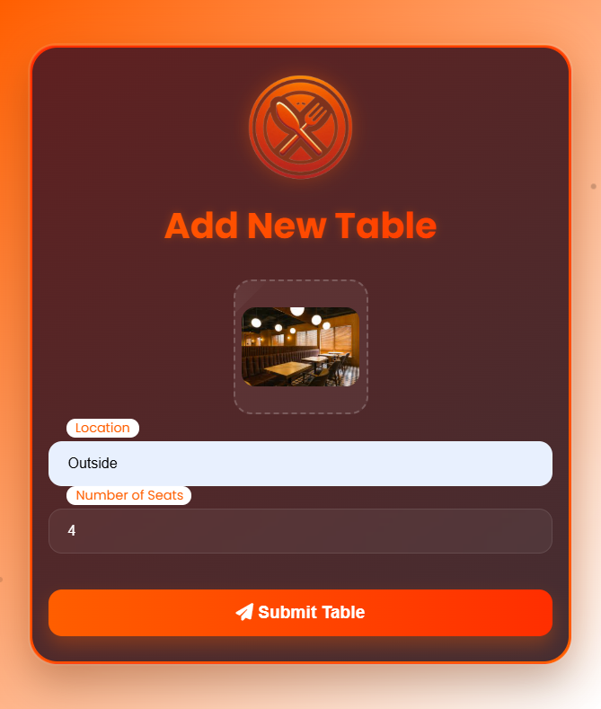



**Chapter 5**

**System implementation**

**5.1 Login snapshot**

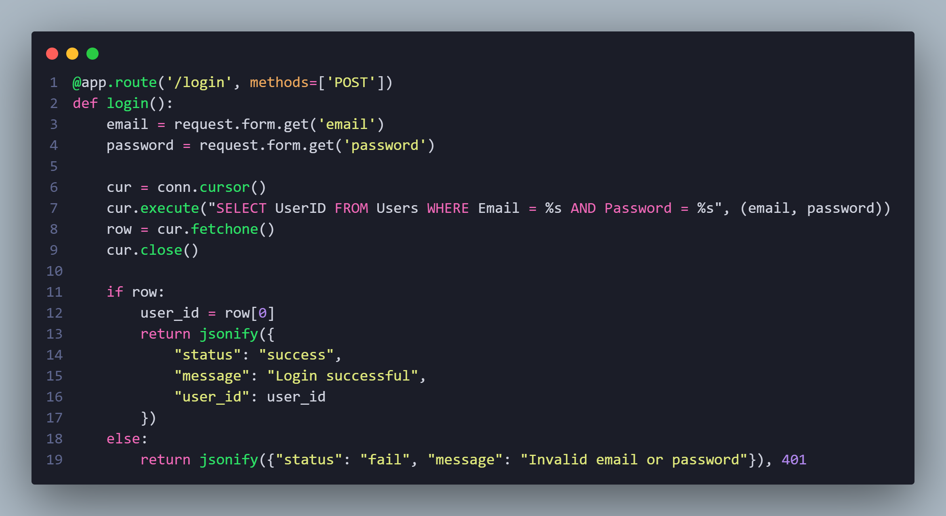**5.1.1 API part**

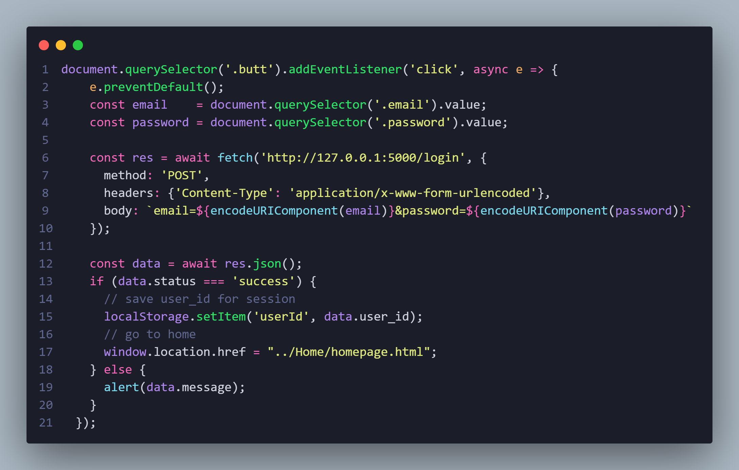**5.1.2 JavaScript part**

**5.2 Homepage data fetching**

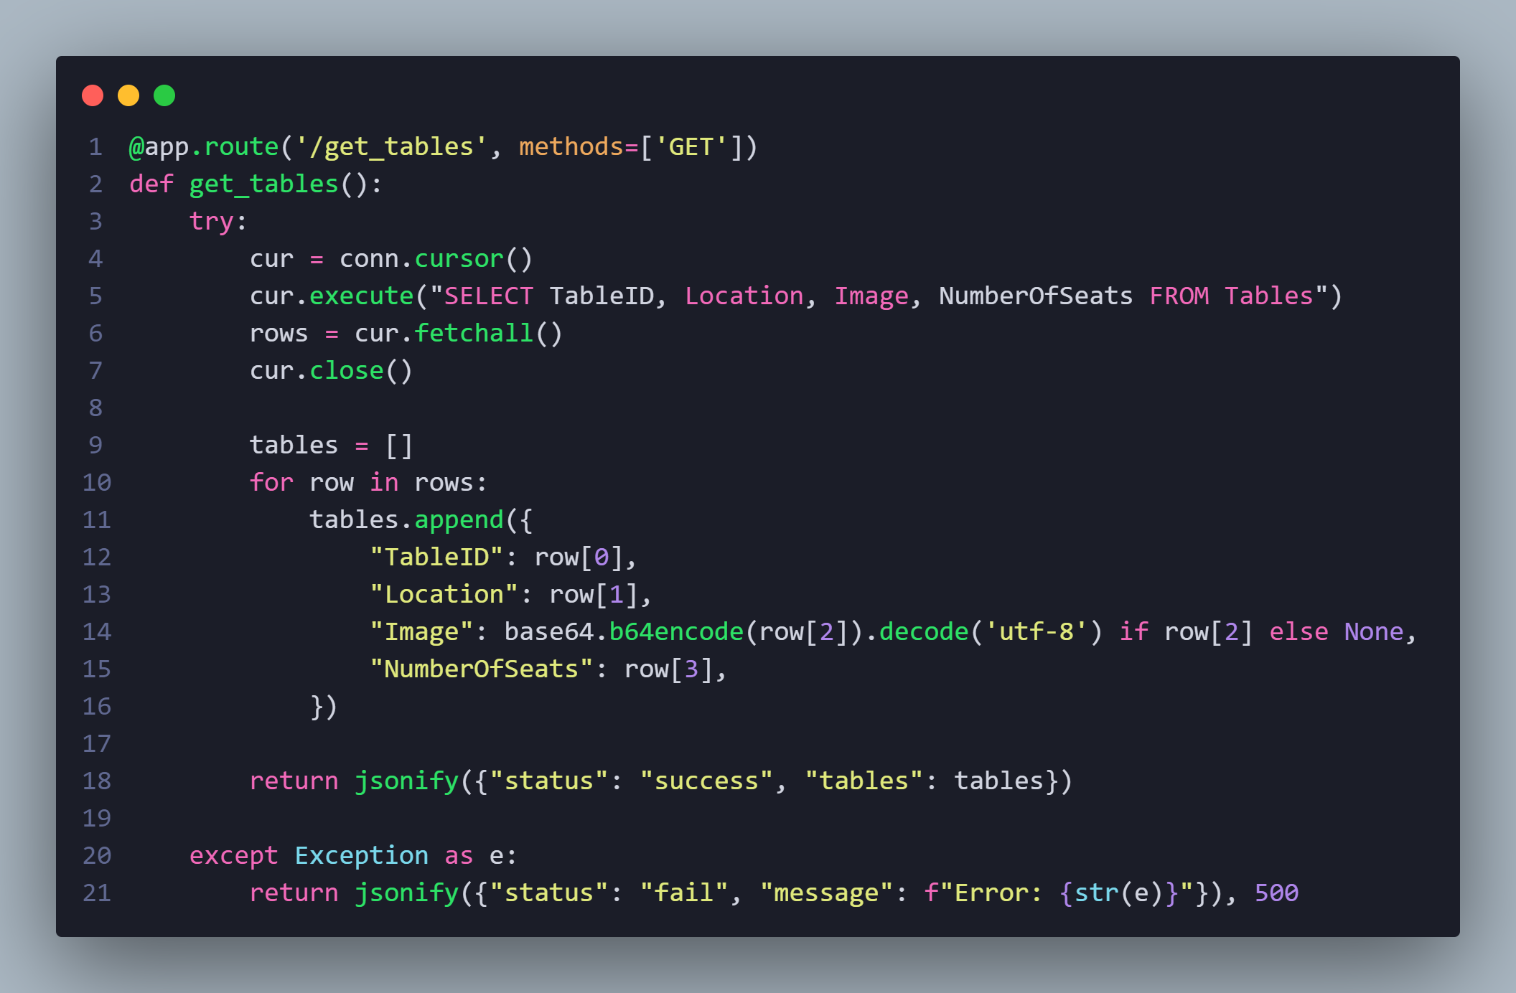**5.2.1 Getting tables (API)**

**5.2.2 Responding in UI**

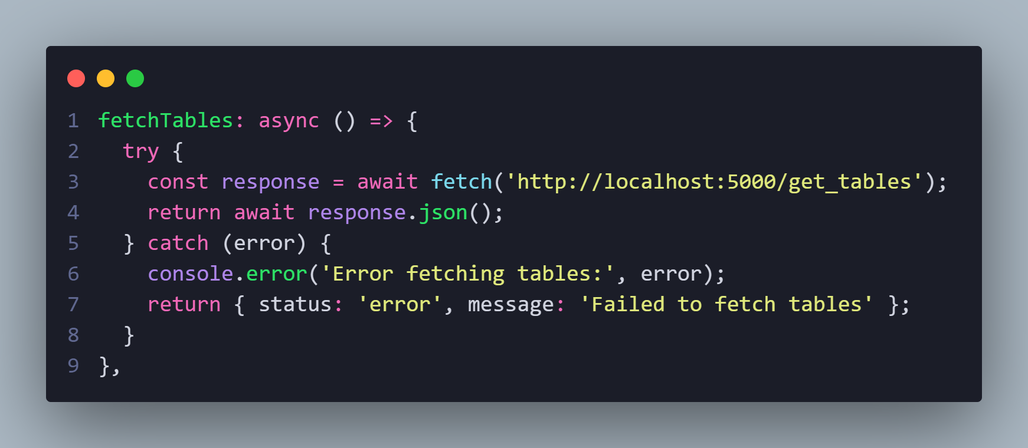

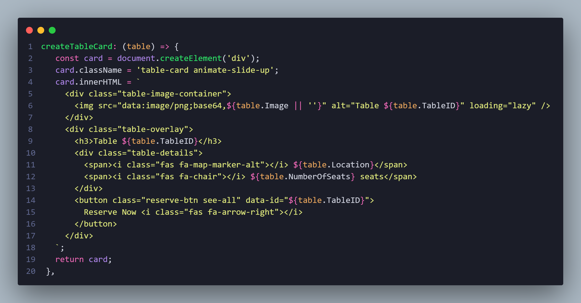**5.2.3 Mapping tables in cards**

**5.3 Reserving (check if already reserved)**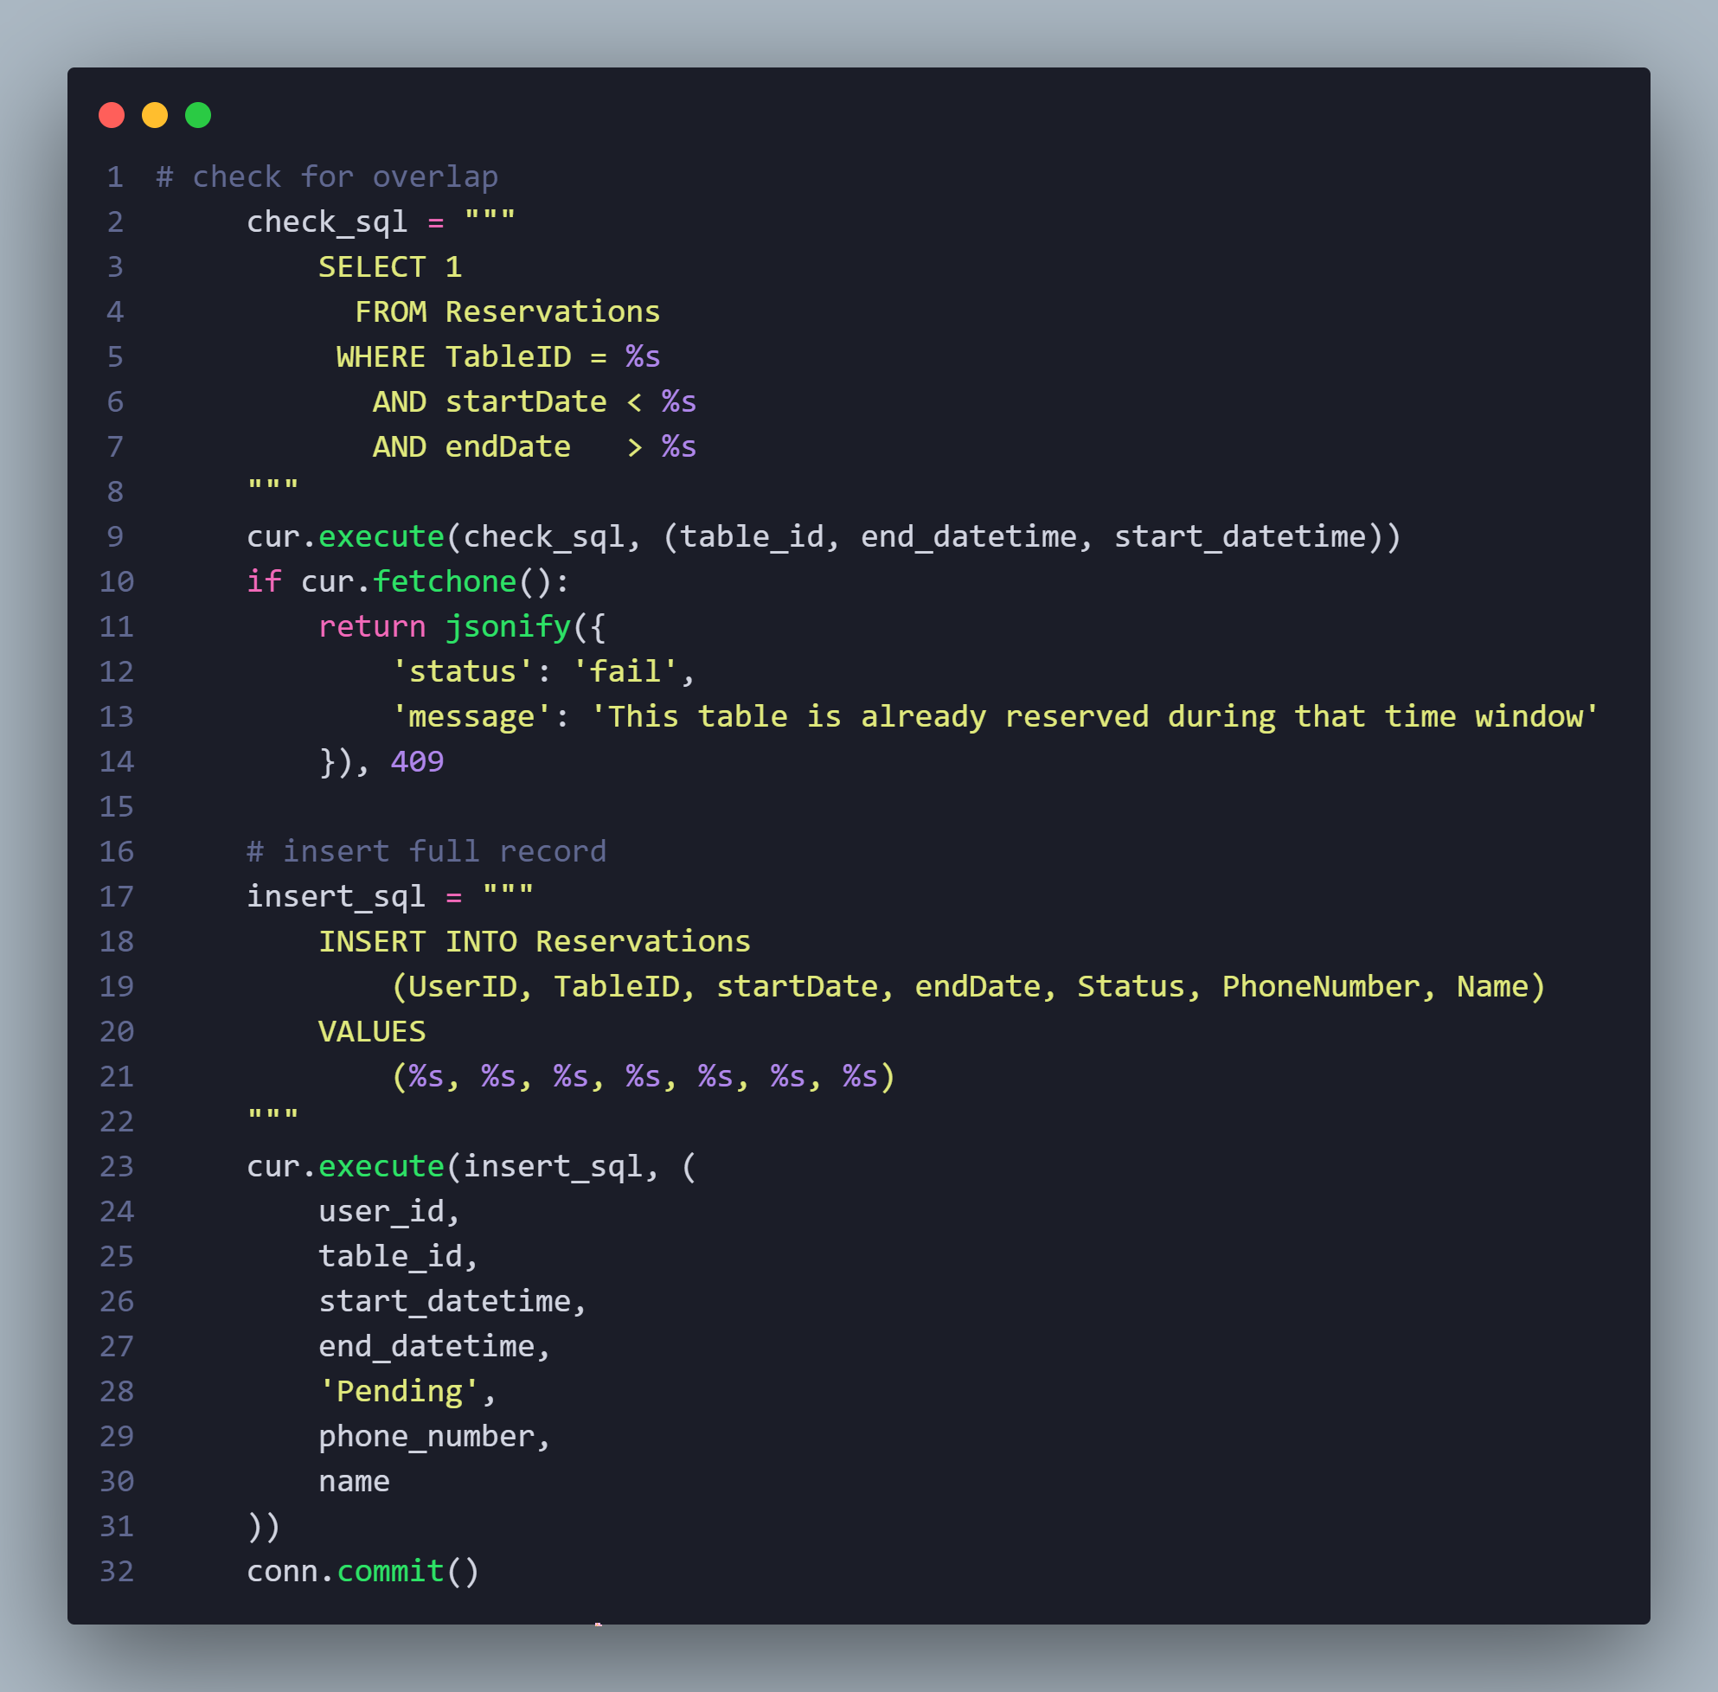

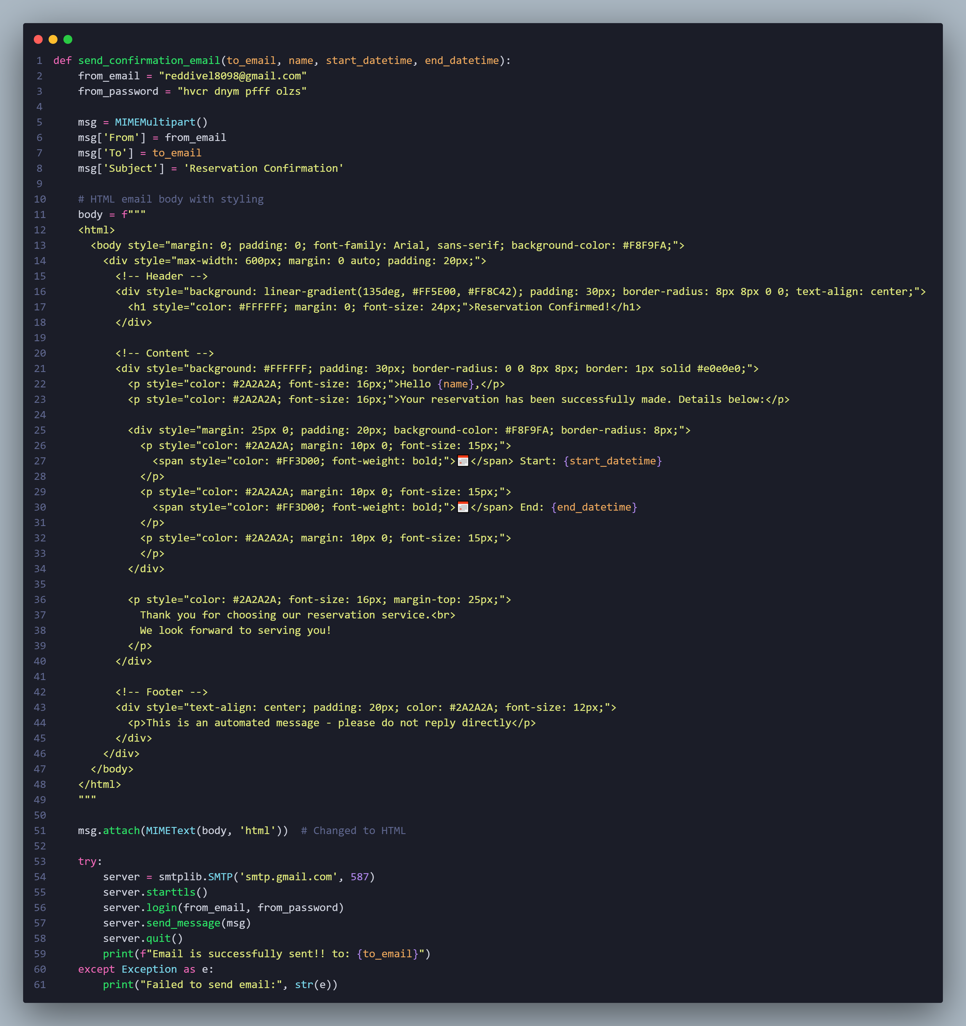**5.4 Send confirmation email**

**5.5 Reservation view**

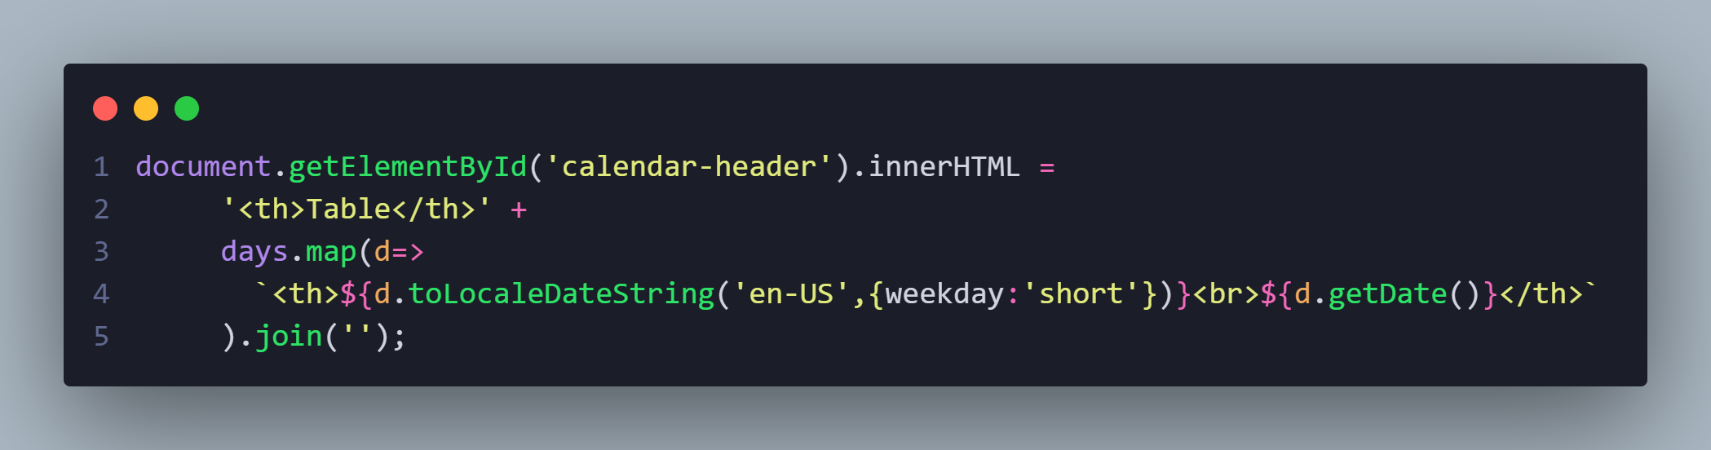**5.5.1 Render tables**

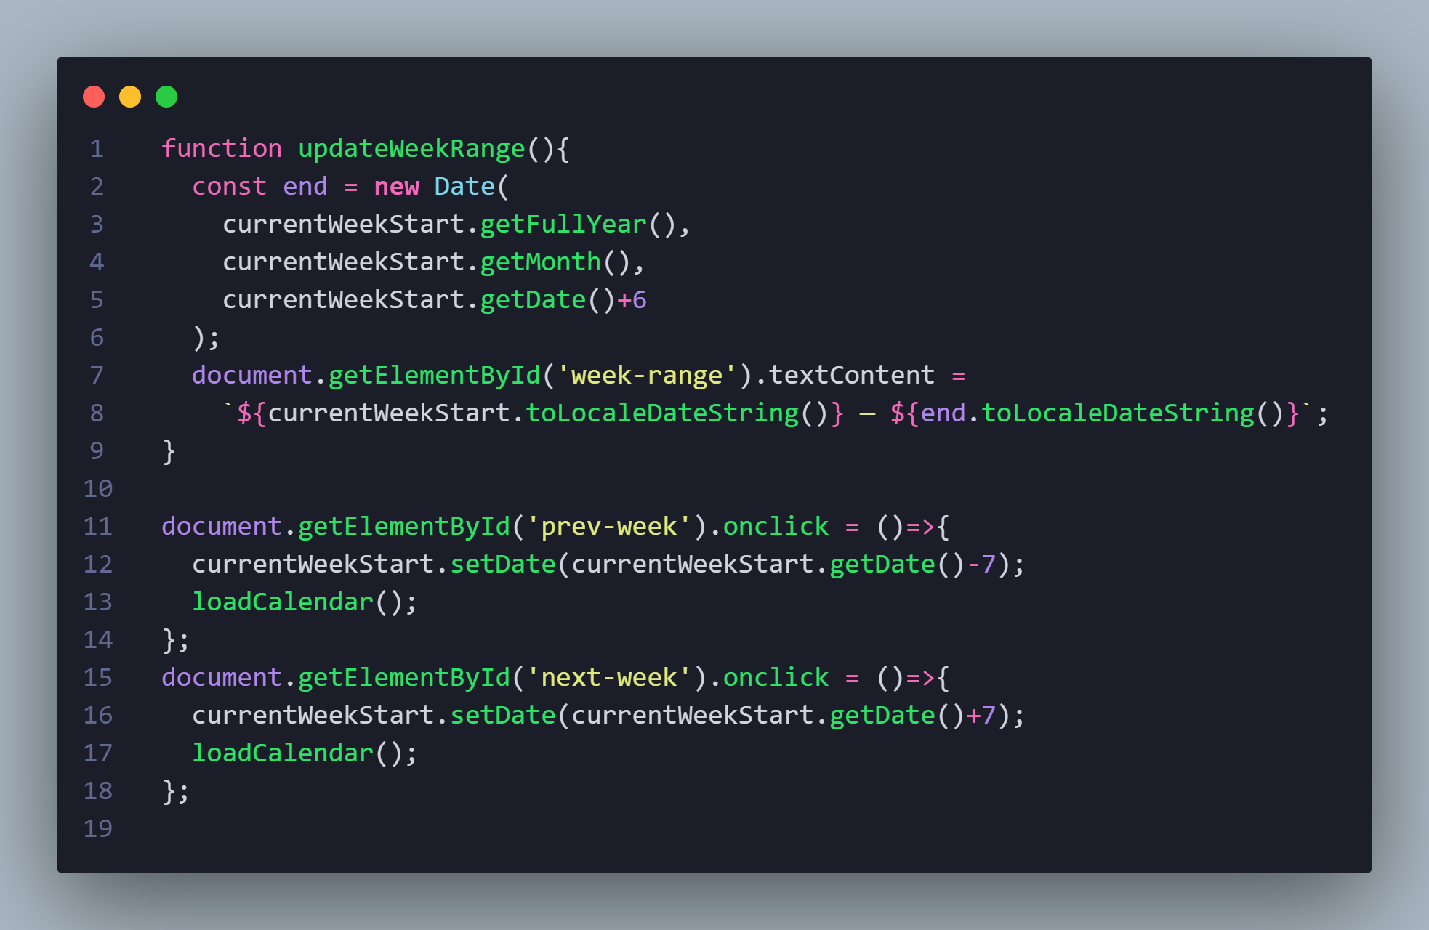**5.5.2 Update week range**

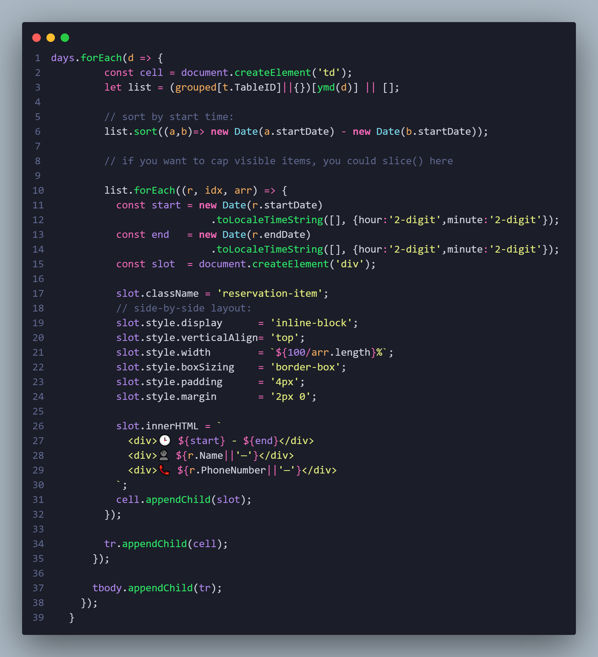**5.5.3 Render reservations**



**Chapter 6**

**Testing**

|  |  |  |  |  |  |  |  |
| --- | --- | --- | --- | --- | --- | --- | --- |
| Test Case ID | Test Title | Precondition | Test Steps | Test Data | Expected Results | Actual Results | Status |
| TC01 | User can reserve with valid data | User is logged in | 1. Log in  2. Fill all fields correctly  3. Click 'Reserve' | All fields filled with valid data | Reservation is successful and confirmation message appears | Reservation is successful and confirmation message appears | pass |
| TC02 | Missing required fields | User is logged in | 1. Log in  2. Leave one or more fields empty  3. Click 'Reserve' | One or more fields left empty | Error message indicating missing fields appears | Error message indicating missing fields appears | pass |
| TC03 | *Reservation attempt without login* | User is not logged in | 1. Open reservation page without logging in  2. Fill all fields  3. Click 'Reserve' | Valid data in all fields | Prompt user to log in before reservation | Prompt user to log in before reservation | pass |
| TC04 | End date before start date | User is logged in | 1. Log in  2. Fill all fields correctly  3. Set End Date before Start Date  4. Click 'Reserve' | Valid name and phone number; End Date earlier than Start Date | An error message appears: 'End date must be after start date' | An error message appears: 'End date must be after start date' | pass |
| TC05 | End time before start time | User is logged in | 1. Log in  2. Fill all fields correctly  3. Set End time before Start time  4. Click 'Reserve' | Valid name and phone number; End time earlier than Start time | An error message appears: 'End time must be after start time | An error message appears: 'End time must be after start time | pass |

|  |  |  |  |  |  |  |  |
| --- | --- | --- | --- | --- | --- | --- | --- |
| Test case id | Test title | Test steps | precondition | Test data | Expected result | Actual result | status |
| TC 1 | Add new menu item | Go to the item menu page, then put a picture of the item, then put the item’s name, then put the item’s price, then click on “Submit Item.” | Login with admin account | Any data | The item was added successfully | The item was added successfully | pass |
| TC 2 | Add new item with Name and price only without photo | Go to the item menu page, then don't put a picture , then put the item’s name, then put the item’s price, then click on “Submit Item.” | Login with admin account | Any data  From name and price | The item cannot be added successfully without the image. | The item cannot be added successfully without the image. | pass |
| TC 3 | Add new item without data | Go to the item menu page, then don't put any data then click on “Submit Item.” | Login with admin account | none | The item cannot be added successfully without data. | The item cannot be added successfully without data. | pass |
| TC 4 | Add new item without name | Go to the item menu page, then don't put a name , then put the item’s picture, then put the item’s price, then click on “Submit Item.” | Login with admin account | Any data from picture and price | The item cannot be added successfully without name. | The item cannot be added successfully without name. | pass |
| TC 5 | Add new item without price | Go to the item menu page, then don't put a price , then put the item’s picture, then put the item’s name, then click on “Submit Item.” | Login with admin account | Any data from picture and name | The item cannot be added successfully without price. | The item cannot be added successfully without price. | pass |
| ID | Title | Pre-Conditions | Test Steps | Test Data | Expected Result | Actual Result | Status |
| Tc-1 | Open Add Table Page | Logged in as Admin | 1. Log in as an admin 2. Open the Add Table page | None | The page opens without any error | The page opened successfully without errors | Pass |
| Tc-2 | Submit Form with Valid Data | Logged in as Admin | 1. Enter location 2. Enter "4" as number of seats 3. Click "Submit Table" | Location = "Hall A", Seats = 4 | Success message appears: "Table added successfully" | Success message displayed: "Table added successfully | Pass |
| Tc-3 | Required Fields Validation | Logged in as Admin | 1. Leave both fields empty 2. Click Submit | Location = "", Seats = "" | Validation messages “please fill in all fields” | Validation message displayed: “please fill in all fields | Pass |
| Tc-4 | Numeric Input Restriction on Seats Field | Logged in as Admin | 1. Click on the seats field 2. Try to enter non-numeric text (e.g., "four" or letters) | Seats input = "four" | Input is not accepted; user cannot type non-numeric characters | Letters were blocked; only numbers accepted | Pass |
| Tc-5 | Submit Form with Location Only | Logged in as Admin | 1. Enter "Hall 3" as location 2. Leave seats empty 3. Click Submit | Location = "Hall 3", Seats = "" | Validation messages “please fill in all fields” | Validation message displayed: “please fill in all fields” | Pass |
| Tc-6 | Submit Form with Seats Only | Logged in as Admin | 1. Leave location empty 2. Enter "6" as seats 3. Click Submit | Location = "", Seats = 6 | Validation messages “please fill in all fields” | Validation message displayed: “please fill in all fields” | Pass |
| Tc-7 | Placeholder Text Verification | Open Add Table page | 1. Check placeholder text in input fields | None | "Where is the table located?" and "How many seats?" are visible | Placeholder texts appeared correctly in both fields | Pass |
| Tc-8 | Submit Button UI Check | Open Add Table page | 1. Check the style of the "Submit Table" button | None | Button is visible, styled, and clearly labeled | Button is clearly visible and styled correctly | Pass |
| Tc-9 | Response on Submit Button Click | Valid data entered | 1. Click Submit button | Location = "Outdoor Area", Seats = 5 | Submission is triggered and response is shown | Submission triggered and success message shown | Pass |
| Tc-10 | Verify Icons Are Functioning Properly | Open Add Table page | 1. Check that all icons are displayed correctly 2. Confirm that icons load without errors and appear in the correct position | None | Icons are visible, correctly placed, and load without issues | All icons loaded correctly and appeared in proper positions | Pass |

|  |  |
| --- | --- |
| TC-ID | DEL-MENU |
| Title | Attempting to delete a menu item |
| Pre-condition | * User has access to the Admin instance * There is an existing menu item |
| Test steps | 1. Access the admin instance 2. Press the Menu card 3. Press ‘Delete’ button 4. Press ‘Confirm’ button |
| Test data | A menu item |
| Expected result | The menu item being deleted along with a successful message |
| Actual result | The menu item is successfully deleted with a message indicating that |
| Status | Pass |

|  |  |
| --- | --- |
| TC-ID | UPD-MENU-1 |
| Title | Attempting to update a menu item’s price |
| Pre-condition | * User has access to the Admin instance * There is an existing menu item |
| Test steps | 1. Access the Admin instance 2. Press menu card 3. Choose an item to alter its price 4. Press ‘Edit price’ button 5. Enter the new desired value 6. Press ‘Confirm’ |
| Test data | * A menu item * New price: 300 |
| Expected result | The menu item being updated with the new price with a successful message |
| Actual result | The menu item’s price is successfully altered with the new price with the new message |
| Status | Pass |

|  |  |
| --- | --- |
| TC-ID | UPD-MENU-2 |
| Title | Attempting to press ‘Cancel’ while updating a menu item’s price |
| Pre-condition | * User has access to the Admin instance * There is an existing menu item |
| Test steps | 1. Access the Admin instance 2. Press menu card 3. Choose an item to alter its price 4. Press ‘Edit price’ button 5. Press ‘Cancel’ button |
| Test data | * A menu item |
| Expected result | The dialogue being closed |
| Actual result | The dialogue is closed successfully |
| Status | Pass |

|  |  |
| --- | --- |
| TC-ID | UPD-MENU-3 |
| Title | Attempting to press ‘Confirm’ with an empty price |
| Pre-condition | * User has access to the Admin instance * There is an existing menu item |
| Test steps | 1. Access the Admin instance 2. Press menu card 3. Choose an item to alter its price 4. Press ‘Edit price’ button 5. Press ‘Confirm button |
| Test data | * A menu item |
| Expected result | A message is displayed indicating that the price can’t be empty |
| Actual result | The message is displayed successfully |
| Status | Pass |

|  |  |
| --- | --- |
| TC-ID | DEL-TBL-1 |
| Title | Attempting to delete a table |
| Pre-condition | * User has access to the Admin instance * There is an existing table |
| Test steps | 1. Access the admin instance 2. Press the tables card 3. Press ‘Delete’ button 4. Press ‘Confirm’ button |
| Test data | A table |
| Expected result | The table being deleted along with a successful message |
| Actual result | The table wasn’t deleted |
| Status | Fail |

|  |  |
| --- | --- |
| TC-ID | DEL-TBL-2 |
| Title | Attempting to press ‘Cancel’ while deleting a table |
| Pre-condition | * User has access to the Admin instance * There is an existing menu item |
| Test steps | 1. Access the Admin instance 2. Press Tables card 3. Choose table to delete 4. Press ‘Delete button 5. Press ‘Cancel’ button |
| Test data | * A table |
| Expected result | The dialogue being closed |
| Actual result | The dialogue is closed successfully |
| Status | Pass |

|  |  |
| --- | --- |
| TC-ID | TBL-PG |
| Title | Attempting to press on an image to see it clearly |
| Pre-condition | * User has access to the Admin instance * There is an existing table |
| Test steps | 1. Access the Admin instance 2. Press Tables card 3. Choose a table to view 4. Press on the table’s image |
| Test data | * A table |
| Expected result | The table’s image being displayed |
| Actual result | The table is displayed successfully |
| Status | Pass |

**Bug report for the failed test case**

|  |  |
| --- | --- |
| Bug-ID | DEL-FUNC |
| Bug title | **Bug in deleting a table** |
| Severity | **High** |
| Priority | **High** |
| Reported by | **Bilal Ahmed** |
| Date | **05/05/2025 7:31 PM** |
| Description | **Couldn’t delete an existing table** |
| Steps | 1. **Access the Admin instance** 2. **Press the Tables card** 3. **Choose a table to delete** 4. **Press ‘Delete’ button** 5. **Press ‘Confirm’ button** |
| Expected result | **The table being deleted along with a successful message** |
| Actual result | **The table wasn’t deleted** |



**Chapter 7**

**Future plans**

* **7.1 Offer Management and Display**  
  The system shall provide administrators with the ability to create and manage promotional offers on specific meals. These offers will be visible to customers through the user interface, enabling them to view current discounts and promotions applied to individual menu items.
* **7.2 Meal Ordering and Delivery**  
  The system shall allow customers to place orders for meals through the application. Once an order is confirmed, it will be processed and delivered to the customer by the restaurant’s designated delivery personnel.
* **7.3 Admin Analytics Dashboard**

A comprehensive dashboard for administrators to monitor key performance metrics such as total sales, top-selling meals, and the effectiveness of promotional offers.



**Chapter 8**

**Ending**

## 8 Conclusion

The Restaurant Reservation and Management System (RRMS) is a forward-thinking solution tailored to meet the evolving demands of both restaurant customers and administrative staff. By addressing the key pain points in traditional reservation methods, the RRMS offers an all-in-one platform that simplifies bookings, enhances real-time communication, and ensures smoother daily operations.

This documentation has outlined the system’s purpose, scope, feasibility, functional and non-functional requirements, and technical foundations. Through features such as real-time table availability, digital menu browsing, automated notifications, and centralized dashboard control, the RRMS aims to boost customer satisfaction while significantly improving operational efficiency for restaurant staff.

With a user-friendly interface, scalable architecture, and modern technology stack, the RRMS is not only suitable for current restaurant operations but is also built with future enhancements in mind. This includes potential integration with loyalty systems, third-party services, and multi-branch scalability.

In conclusion, the RRMS stands as a reliable and impactful tool in the digital transformation of the hospitality industry — making dining experiences smarter, smoother, and more engaging for everyone involved.



**Thank you!**